This advertisement was featured in magazines across the UK in the 1950s. When this campaign started, society was in a post-rationing period.

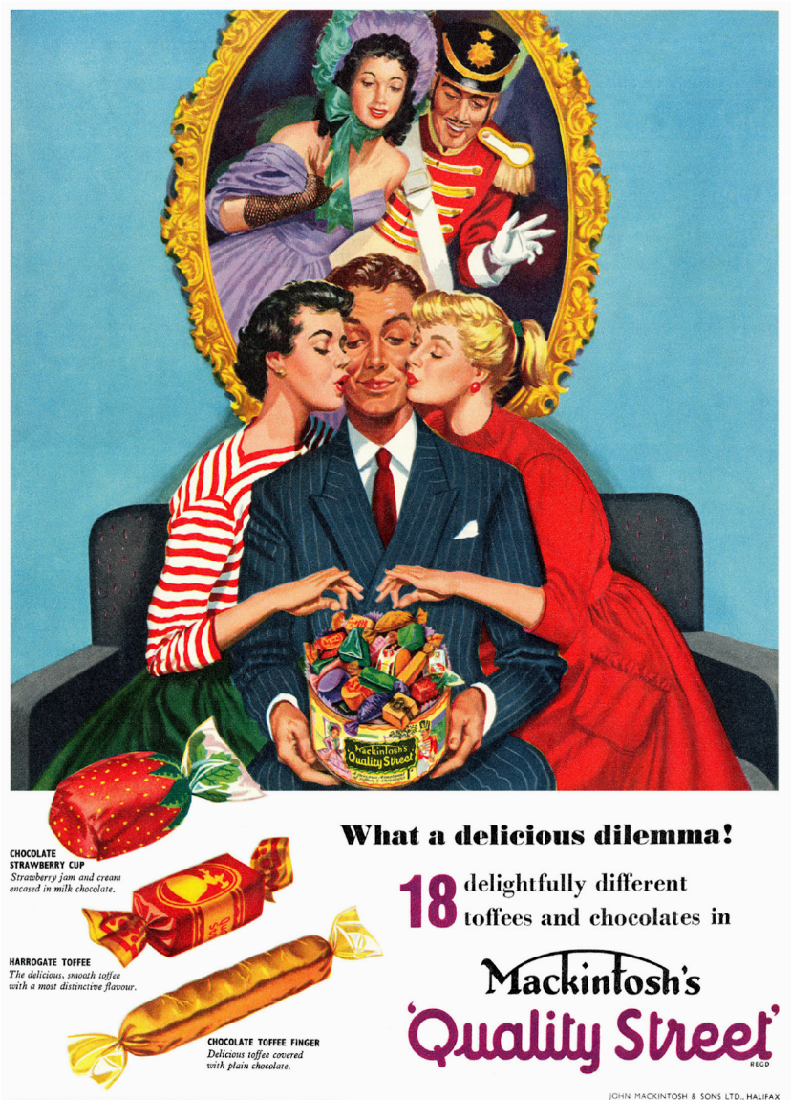

Gender roles in the 1950s were remarkably different to the present day. The British society was highly patriarchal (male dominated) in both the family household and the working environments.

This is yet another similarity between the 1950s and the Regency era.

The advertisement was inspired by a play by J.M.Barrie and features the main characters from the Regency era Miss Sweetly and Major Quality.

The 1950s and the Regency era are comparable due to the fact that both eras saw advancements in social and cultural development. Fine art, luxury items and elegance were becoming more widely accessible to the middle and working class.

Mackintosh aimed the advertisement towards the working and middle class which aspired to raise the social structures. This correlated with the Conservative Party’s election campaign (1951) slogan “set the people free”.

Male choosing between two women. With the sweets on his lap.

Females choosing which sweet to eat.

**Golden frame centred above the man and over his head.**

Female characters wearing red, white and green outfits.

Regency characters wearing upper class and fancy outfits.



How does the advert apply to dominant ideologies?

How does this advertisement portray the representation of gender?

Why have the producers of this advert selected this specific image to front their campaign?

Chocolate tin overflowing with chocoltes.

Persuasive language techniques (alliteration, emotive language, superlatives).

Regency characters wearing upper class and fancy outfits.

Women kissing the man whilst taking a sweet from the tin.

**Man wearing a business suit.**

**Serif and purple typography “Quality Street”**

Hand-drawn and artistic nature of the design, with a rich colour palette.

What are the connotations of the tagline “What a delicious dilemma”? Where can we see examples of a dilemma?

Conduct research from other early 1950s advertisements on the role women held in society, at home and within advertisements.