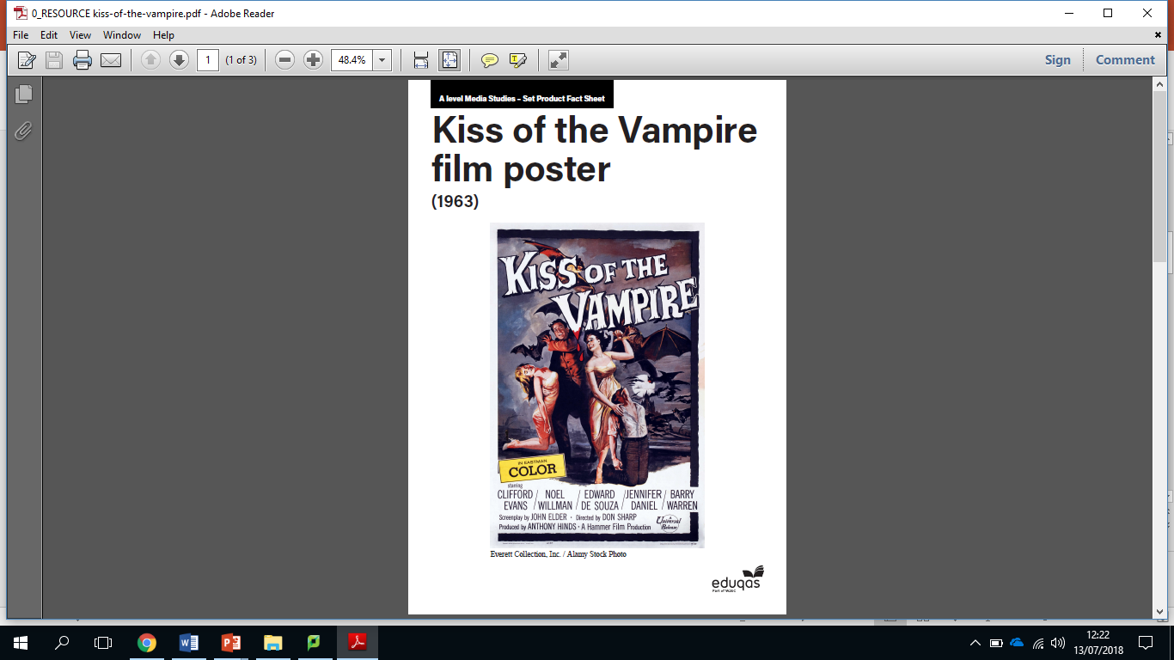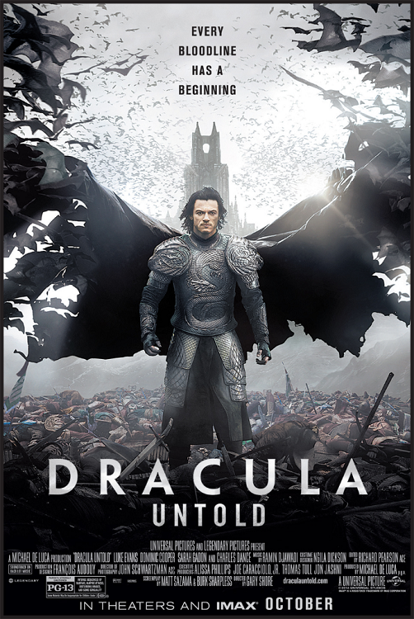

Paragraph 6 Source B **(Composition) Comparisons needed!**

Audience Positioning:

How the positioning achieved through representation:

Evidence:

Explanation (Realism/Stereotyping etc.):

Evidence 2:

Explanation (Realism/Stereotyping etc.):

Link to Context:

Theory (Optional):

Paragraph 5 Source A **(Composition)**

Audience Positioning:

How the positioning achieved through representation:

Evidence:

Explanation (Realism/Stereotyping etc.):

Evidence 2:

Explanation (Realism/Stereotyping etc.):

Link to Context:

Theory (Optional):

Paragraph 3 Source A **(Language)**

Audience Positioning:

How the positioning achieved through representation:

Evidence:

Explanation (Realism/Stereotyping etc.):

Evidence 2:

Explanation (Realism/Stereotyping etc.):

Link to Context:

Theory (Optional):

Paragraph 4 Source B **(Language) Comparisons needed!**

Audience Positioning:

How the positioning achieved through representation:

Evidence:

Explanation (Realism/Stereotyping etc.):

Evidence 2:

Explanation (Realism/Stereotyping etc.):

Link to Context:

Theory (Optional):

Paragraph 2 Source B **(Image) Comparisons needed!**

Audience Positioning:

How the positioning achieved through representation:

Evidence:

Explanation (Realism/Stereotyping etc.):

Evidence 2:

Explanation (Realism/Stereotyping etc.):

Link to Context:

Theory (Optional):

Paragraph 1 Source A **(Image)**

Audience Positioning:

How the positioning achieved through representation:

Evidence:

Explanation (Realism/Stereotyping etc.):

Evidence 2:

Explanation (Realism/Stereotyping etc.):

Link to Context:

Theory (Optional):

Introduction

Overall positioning of the audience of Source A:

Overall Representation in Source A:

Overall positioning of the audience of Source B:

Overall Representation in Source B:

Summarise ways in which the audience are positioned to feel/think.



Summarise ways in which the audience are positioned to feel/think.



Compare how audiences are positioned by the representations in Resource A, the Dracula film poster **and** the Kiss the Vampire film poster you have studied as part of the set products.

In your answer you must:

* Consider how the representations construct versions of reality
* Consider the similarities and differences in how audiences are positioned by the representations
* Make judgements and draw conclusions about how far the representations relate to relevant media contexts. [30]