Comprehension Questions
- What is the purpose of the “Evryman” men’s group?

- Who is argued to be effected by patriarchy

- What issues are men facing within society?

- How did the author try to maintain a masculine persona when growing up in the 2000s?

- What are men rewarded for in modern society?

- What is the aim of the “Evryman” group?

- What were some of the reasons that men went to the “Evryman” group?

- What was the alternative point of view about the “Evryman” group given by feminist Heidi Sieck/

- What was bell hooks’ view of the “Evryman” group?

- What is homohysteria and why does the author say that it is an issue?

Summative Questions
- What is the overall message of the article?

- What can we infer about GQ’s values?

- What viewpoint does GQ have of masculinity?

My Time Inside a Group Where Men Confront Their Feelings
Each week, at an apartment in Brooklyn, a small collection of guys get together to sift through and discover some of their deepest feelings—their secret fears, their hidden desires, their private shortcomings—in the hope that they can become better men. It's a messy, emotional, imperfect project that's part of a growing movement of men reexamining the expectations of masculinity. And it has changed my life.
BY
BENJY HANSEN-BUNDY
PHOTOGRAPHY BY
MATTEO MOBILIO
October 29, 2019
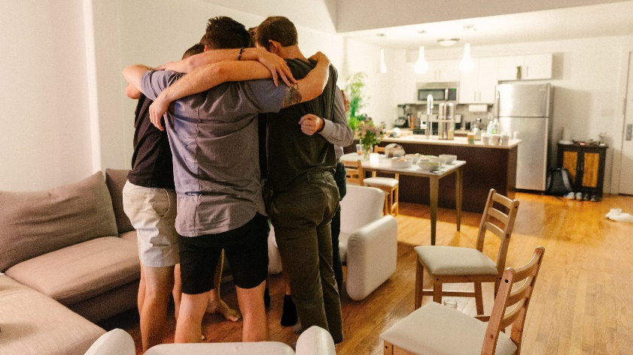

Welcome to GQ's New Masculinity issue, an exploration of the ways that traditional notions of masculinity are being challenged, overturned, and evolved. Read more about the issue from GQ editor-in-chief Will Welch here and hear Pharrell's take on the matter here.
In a loft in Williamsburg, I joined six men sitting in a circle, our bodies propped up on a variety of chairs and a sectional sofa. The guys had pretty good posture. I was doing my best to stay cross-legged. The smell of burnt sage hung in the air. Bowls of homemade guacamole and hummus and a big bottle of kombucha rested on the kitchen table nearby. Also nearby was a mini trampoline that the host, Nathan, liked to jump up and down on every now and then to get his blood flowing and shake his energy loose.
It was my second night in an Evryman men's group, and much as the trampoline unsettled me—who would sacrifice precious Brooklyn square footage for this hokey self-help device?—I was excited. The previous week, I'd gotten my first taste of the emotional release that this environment can offer.
In an effort to prove that this was a safe space, one in which I could be vulnerable, Nathan suggested that we go around the room and have everyone quickly share their “unspeakables.” I asked what an “unspeakable” was. He explained that it was the thing you had never felt comfortable saying to anyone, not even your therapist, maybe not even yourself.
“I'll start,” one guy said. “I've slept with prostitutes.”
The next guy in the circle said, “I'm uncomfortable with my penis.”
There were murmurs of agreement.
Then: “I've cheated on my wife. And I have a history of shoplifting.”
And: “I was in a cult, and I had sex with a guy.”
It was an agonizing exercise. The guys were not exactly proud when they said these things, but they weren't overly embarrassed, either. I tried to nod at each one in solidarity, but I ended up just awkwardly bobbleheading.
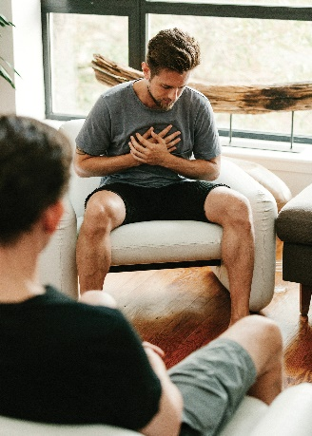
Now, I had been in many all-male spaces before—and when topics like these came up, they often elicited misogynistic or homophobic reactions. But something different happened here. These guys had created something rare: a space where men felt safe enough to let their guard down and express the parts of themselves that they otherwise make little to no contact with—including the parts they're most ashamed of.

Evryman has its critics, but author Esther Perel says it helps “rewrite the script” on masculinity, which is “good for men and women both.”

Men's groups seem to be having a moment. Late last year, the New York Times Style section did a trend piece that surveyed the expanding landscape of organizations cropping up to foster emotional openness and masculine repair-work. The definition of a men's group can vary. There are expensive weekend retreats to rediscover positive masculinity, like Sacred Sons and Junto. There are shouty boot camps where midlevel executives find their inner warrior, like Warrior Week. And then there are Brooklyn-y support groups where men sit around in a circle with the purpose of getting in touch with—and learning how to express—their feelings, like ManKind Project. My Evryman group fell into this last category. (Of course, none of these self-betterment projects ought to be confused with so-called men's-rights groups, the more hostile of which lurk in the gutter swamps of the web, trafficking in the worst kinds of antagonistic, anti-women rhetoric and even spurring some men to violence.)
The first men's groups showed up about 40 to 50 years ago, after the rise of the women's liberation movement of the '60s and '70s, perhaps in response to the prevalence of women's groups at the time. A 1982 study of men's groups found that the purpose of these was “to encourage examination of how the masculine gender role is experienced by individual men and to explore new ways of enacting this role.” But because the majority of politically, economically, and socially powerful positions were held by men, most guys had a hard time questioning the traditional masculine gender role, even if, on an individual level, they derived little from it. As the study said, “they still have an association with power simply by being men.”
But the patriarchy hurts everyone. While it goes without saying that the far greater toll is levied against everyone who's not a straight male, straight men pay a price too. As far back as the 1970s, research began showing that, for all the privileges conferred on them in society, men were dying younger than women. They were committing and being victimized by more crimes as well. More men also die by suicide and drug overdose on opioids, and they tally a higher incidence of chronic disease than women do. Researchers, authors, and activists have all pointed, in different ways, at the narrow definition of what it means to “be a man” in America—being authoritative, taking risks, hiding any signs of weakness—and how, in their efforts to embody that characterization, men end up hurting themselves and everyone around them.
In 2015, Gloria Steinem put it like this: “Men's life expectancy increases by three to four years if you deduct from all the reasons that men die those that could be reasonably attributed to the masculine role. Death from violence, death from speeding, from tension-related diseases.”
The idea that “patriarchal masculinity estranges men from their selfhood,” as bell hooks wrote in All About Love back in 2000, still feels transgressive, somehow, even if it's accepted in academia and parts of the media. That's because it's a tricky idea. It contradicts the premise that men are in control of what's happening to them. “The popular feminist joke that men are to blame for everything is just the flip side of the ‘family values’ reactionary expectation that men should be in charge of everything,” Susan Faludi points out in Stiffed: The Betrayal of the American Man, her deeply reported look into the state of masculinity. “The problem is, neither of these views corresponds to how most men feel or to their actual positions in the world.”
As I came of age in the 2000s, the message I got from the culture and from the other boys on the playground was that masculinity was most easily defined by what it wasn't: gay. My anxiety to avoid doing anything that could be called “gay” was especially strong in middle school. I basically installed a “that's gay” alarm system in my body—and kept it on a hair trigger—to the point where I avoided doing anything “gay,” even in private. Crying? “Gay.” Wearing a Speedo? “Gay.” Getting too close to another guy, outside of the basketball court? “F***ing' gay, dude.” Since then, I'd been in just about every all-male group context you can think of: sports teams, dormitories, a fraternity, even a men's magazine. Each had varying degrees of homophobia, varying levels of emotional openness, varying forms of acceptable male intimacy. In each, I proved my straightness in different ways.
Fast-forward 17 years, I was 29 and I was all clammed up emotionally. I was recovering from a recent breakup, I'd just started psychotherapy, I was reading bell hooks. But I still felt disconnected from my feelings. When I stumbled upon Evryman, I knew right away that the gooeyness of it, the New Agey earnestness, everything that made me want to run in the opposite direction—all that stuff was exactly why I had to jump in. So I…put it off for three months. But then I hit 30. And when you hit 30, a good question to ask yourself is “What am I holding out for?”
Evryman was founded by Dan Doty, Lucas Krump, Sascha Lewis, and Owen Marcus in 2017. They had prior experience in men's groups—Owen's going back as far as the 1980s. The premise for Evryman was actually pretty simple: provide men a safe space to practice being vulnerable so that they could bring greater emotional intelligence into their relationships, their friendships, and their work. Or, translated into old-school guy-speak, what Lucas likes to call “CrossFit for your emotions.”
Evryman has more than 1,000 men, attending more than 100 groups around the country. The groups are free. Where Evryman makes its money—it's structured as a benefit corporation, which means it's for-profit with a social mission—is on pricey weekend retreats, like MELT (Men's Emotional Leadership Training) and Open Source, and from corporate group work facilitation. It's also developing programming that includes men and women in the circle together. Dan Doty recently led a coed discussion on sexual violation, gender inequality, friendship, and intimacy. But for now, the core of the Evryman experience is the weekly men's groups, which operate mostly autonomously, following a loose script and with members occasionally seeking guidance from the leadership.
What makes any support group successful, in addition to honesty, vulnerability, and safety, is diversity of perspective. Evryman has failed, so far, in this last regard. Most of its members, and nearly all of its leadership, are straight and white. That's the case in my group as well.
We gather every Monday night from 6:45 to 9:45 p.m. at Nathan's apartment. Each man has 10 minutes to share what's going on in his life while the rest of the group listens closely and challenges him to go deeper when he gets off track. He might laugh or cry or scream into a pillow. That is followed by two minutes of feedback from the group. If anyone is “feeling hot”—if he's going through a particularly painful moment in a divorce, let's say—he can ask to go for a second, longer session at the end of the night.
“I begin to realize that my world doesn't collapse if someone else sees me have an emotion. it seems so simple now, but it came as a revelation.”
Here's the thing: Guys, across our culture, are “feeling hot” right now. The demands of modernity, specifically around emotional intelligence, are higher. Men—and this is my impression both as a man and as an observer in this space—often don't have the tools to meet those demands. This is, in part, why you hear women in relationships with men speaking up about having to do so much emotional labor. Guys are ill-equipped to pull their weight in this regard. Because even if the understanding of what masculinity can be in this country is evolving, traditionally speaking, men are actually rewarded for the opposite, for being disconnected from their emotions. That's how they can perform all those traits of stereotypical masculinity, like not crying. Now guys are being asked by their partners and their communities to perform at a much higher emotional level, and for good reason: As a society, we're beginning the process of reckoning with male privilege.
Unsurprisingly, a number of the men in my group pointed to #MeToo as being one of the catalysts for them to join. In a moment of collective soul-searching, some men hunkered down into foxholes, refusing to acknowledge a structural problem, others rededicated themselves to allyship, still others acknowledged that they had some real work to do before they could become effective allies and so set about the process of increasing their emotional intelligence.
Evryman aims to provide a space for guys to work on those skills, to learn how to express anger, shame, joy, and love. It doesn’t claim to be the panacea for solving relationships between men and women. It definitely doesn’t claim to have the answer to #MeToo or to Brett Kavanaugh. It doesn’t even try to define what masculinity is. It keeps that open-ended. It’s up to the individual members to define what masculinity means to them.
What Evryman does claim is that it can help men become more than “emotional third graders” and start building the tools necessary to even join the broader conversation. That is, in part, why the groups are all-male. At first this aspect of it made me skeptical. Isn’t it all too typical of men to try to solve the problems created by gender inequality in a room that excludes women? The reality, I think, is that many men actually aren’t yet ready to have an adult conversation with women about these issues. And that whatever happens in men’s group is the work men need to do before they come to the table.
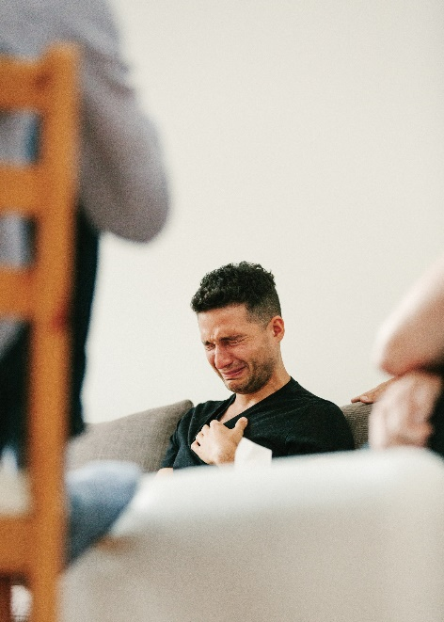
My Evryman meeting begins with a meditation. That’s how we “drop into our bodies.” Deep breathing stimulates the vagus nerve, which slows the heart rate. The vagus nerve affects the parasympathetic nervous system—when that’s activated, you feel relaxed and good things like laughing, crying, sex, and play happen. Deep breathing helps you gear shift out of the sympathetic nervous system, which is the one that’s triggered when a car horn blasts in your ear, your cortisol spikes, and you jump into fight-or-flight mode.
I watched these dynamics play out one evening as Brian shared about his dad. What follows is a good example of what Evryman guys call “doing the work.” After the meditation round, Brian volunteered to go first. He started by telling us how just an hour earlier he really didn’t want to come. He said he really wanted to just numb out by watching movies instead. Then he told us how he didn’t feel seen or loved by his father, who he said was physically and verbally abusive.
“I just have this anger that keeps recurring,” he said. “I feel like something new triggers it every week. I feel like I’m holding a lot of shit.”
“Where?” someone asked.
“Where is this shit, like, in my body?” Brian said.
“Mm-hmm.”
“It’s mostly in my stomach. I feel it in my solar plexus too. It’s a mix of that anger and then fear. I have a true fear of disappointing myself and those I love. I’m afraid that by the time I die, I will not have lived up to my potential, my projection of what my life should be. It feels good to say that out loud. It’s related to my dad, being a failure in his eyes.”
Brian hunched over and started to growl.
“What’s that?” someone else asked.
“I’m feeling this stuckness. Not being seen or not being heard. And then, like, acting out.”
“What do you need to say?”
“I’m good enough. I’m good enough. I can do it. I’m doing my best. I’m doing my best. I’m competent. I’m capable. Listen to me. Just listen to me. See me.…”
He paused and then went on, “I never felt that secure as a child. I didn’t feel like my father really saw me. My mother, while she gave me physical love and attention and words of affirmation, she didn’t really listen or hear my needs, my emotional needs.…”
He cried, took a deep breath, exhaled, and then said calmly, “I feel like I’m seeing little Brian, my child self, and I’m just holding him.”
I asked him about all this stuff a few weeks later. We met for lunch in a park in Manhattan’s financial district. As we balanced take-out bowls on our knees, I asked him if he consciously tried to be different from his dad when he was parenting his own children. He said that wasn’t exactly it, that when he’s parenting, he’s too in the moment to be thinking so theoretically.
“There are times when I get angry and I take it out on them by yelling,” he said. “I’ve been too physical with them. And that hurts to know that you’re replaying what you don’t want to happen.”
That’s why he’s in Evryman, he said. “I want to grow not just for my sake but for their sake.”
Evryman wouldn’t want me to suggest that men’s groups are a good replacement for individual therapy. But as my therapist himself pointed out, the group was performing a similar role in one crucial sense: It was like exposure therapy for vulnerability. I got to practice being vulnerable and being seen, in all my flaws, by other humans. That’s at the heart of what therapy does too. Except with just one person seeing you instead of six. I begin to realize that my world doesn’t collapse if someone else sees me have an emotion. It seems so simple now, but it came as a revelation.
That isn’t to say that my feelings toward Evryman were uncomplicated. My cringe sensors went haywire whenever the guys messaged one another on group chat. Somehow the holistic, affirmational language that I could handle in person—“speak your truth” or “hold the space”—came off as wildly earnest when discovered on a handheld device. Taken out of the safe space, stripped of body language and context, and injected into the same feed as every snarky meme I’ve ever snickered at, these guys sounded cheesy as hell.
Maybe part of the issue is that I work in media and my feed is particularly jaded. But there’s something that feels inauthentic when the guys in the group post all their authenticity online. There’s no way around the fact that, for example, posting a vlog of yourself dancing alone in Prospect Park at sunrise is corny. It just is. It’s like these guys have forgotten how to be embarrassed.
But here’s the thing: While some guys gravitate toward these groups because they feel lonely and have a lack of male companionship in their lives, I do not. I come from a place of abundance in terms of male intimacy with my dad, my brother, my close friends. So for me it doesn’t really matter that I’m not super drawn to every guy in the circle as a friend. I love them and cherish their presence in group, but it doesn’t really matter who they are, as long as they show up all the way on Monday night. For some guys, however, developing real friendships with other men is a crucial part of the experience. Male loneliness has reached epidemic proportions in part, some researchers say, because men are often reluctant to show the vulnerability necessary to deepen a friendship.
One question that came up from the audience was: Why isn’t there any direct messaging from Evryman to its members around crucial topics like sexual assault? The answer to that was a little slippery. Politics didn’t enter into Evryman’s mission, Sascha explained. Evryman was focused on emotions. All the political-awakening stuff was downstream from the emotional-development stuff. Increased social awareness would be, at most, a by-product of “the work.”
The best response I’ve heard from people in the Evryman world is that the all-male setting allows men who are just beginning this process to be more vulnerable than they would be with women also present in the circle. Once these guys start getting better at emotional work, the whole single-gender thing matters less. Or, as Nathan put it, you do “a level of self-healing, development, maturity, and communication in a way that you can then sit down with women at the table and let the real healing begin.”
I called up Heidi Sieck after the event to see if she was satisfied with Evryman’s answers. She wasn’t really. She supported what Evryman was doing. She thought men doing emotional work was super important. Critical, even. And she knew that building trust and being vulnerable take time. But what she didn’t get from Evryman, and what she herself was feeling acutely, along with many other women at the event that night, was a sense of urgency. The major question for Evryman that remains unanswered was, as Heidi put it, “Do you see us? Do you see that we are struggling in your world? Do you see that the whole world is organized in a particular system? We’re not sure that you see that it’s not organized for us. And it’s really hard. Everything feels really hard. Everything from how do we get up the [professional] ladder to what do we wear to how do we date. It’s f***ing exhausting. And we’re doing a ton of emotional labor. Do you see the struggle? Can you have compassion for the struggle over here? We need help. Not in a damsel-in-distress way. We need you voting on our side. We need you to be supporting us in our rise to leadership. We need you all to be giving us opportunities at work. We need you to be treating us as human beings. We need you to listen to our voices.”
And the answer is, I don’t think men’s groups are going to do all that. The ability to see women—to really see them, and maybe also to be seen in an honest way by them, that feels like Evryman 2.0. It’s possible that great allyship of women grows out of men’s work, but it’s not a direct product. That’s the next step. The problem is, as Heidi says, Roe v. Wade might get overturned next year, and we don’t have a lot of time.
One thought leader in this space, relationship therapist and best-selling author Esther Perel, is very much on board with Evryman. She’s even participated in workshops with the organization. She wrote to me in an email: “Never has it been more important to define what it means to be a man and never has it been more difficult. This is why groups like Evryman are well timed and important. They’re part of a new rise of workshops for men which build solidarity and support for men seeking to strengthen their emotional and relational health. By bringing men together to rewrite the script on modern masculinity, these groups end the emotional isolation and promise to help men move beyond antiquated positions of defense to new perspectives on what masculinity could be and become. That’s good for men and women both.”
In The Will to Change, bell hooks wrote that “masses of men have not even begun to look at the ways that patriarchy keeps them from knowing themselves, from being in touch with their feelings, from loving.” I would argue that Evryman has begun that process. Although it seems to be trying to do it without once mentioning the word “patriarchy.” I doubt hooks would approve of the omission. And in a way, it’s an important signal of Evryman’s purpose. It actually isn’t out to fix the patriarchy. It’s out to fix individual men.

Back to my second night in group: All the other guys had already shared their unspeakables. It was my turn, but I didn’t know what to say exactly. So I just started talking. I talked about this feeling I’d had that I’d been pandering professionally for the past few years—writing stories that were relatable or palatable, things I thought people would want to read in GQ. I told them that the things I really wanted to write about were too…dark.
“What do you need to let rip right now that you’re not sharing?” one of the guys asked me. I couldn’t be sure exactly who it was, because my eyes were closed and I was still learning everyone’s name.
“All the sides of myself that I feel aren’t fit to print,” I said.
“Just tell us one right now,” another voice said.
“You know, like the…” I paused and took a breath. “Oh, man, I don’t want to,” I said, shaking my head.
I still wasn’t exactly sure what was so “dark” that I didn’t want to say it out loud. I could think of several things—past misdeeds, evil thoughts, taboo fantasies—but none of them seemed so bad I couldn’t share them in the group setting, especially after what everyone else had said. Already in my short time in group, one guy had shared about his abusive father. Another had a brother who disappeared for two years, hooked on opioids. Another was adopted and was just making contact with his biological parents. Whatever it was I couldn’t say surely wasn’t bigger or harder than these challenges.
“Spit it out,” someone said.
“Now’s the time,” said a voice I knew belonged to Brian. “Do you wanna get vulnerable in this room, or do you wanna bullshit?”
I made a bad joke to stall for time.
“Would you feel lighter if you shared?” Nathan, the host, asked me calmly.
Pause.
“Mm-hmm,” I murmured. And then, adrenaline thundering in my temples, I went for it, speaking off the cuff about an idea that wasn’t even fully formed in my head. It just sort of came out.
“I feel like the normal masculine energy is to penetrate. But the idea that I can’t stop obsessing about is the other, the opposite: being penetrated.”
“How does it feel saying that?”
“It feels great.”
I opened my eyes. I told them about my latent homophobia—directed not toward others but toward anything inside myself that could be perceived as gay. I told them about how I felt I was still defending myself against a seventh-grade bully who called everything “gay.” How, when I was in yoga class and the guy next to me accidentally touched me with his arm, the “that’s gay” alarm bells went off—even though I knew that it wasn’t gay, and even though I knew that there’s nothing wrong with gayness. I grew up in a very progressive household and community and had the message beamed from very early on into my little brain that it was okay to be gay. Duh. I had even told a few people that I was 70 percent straight. Actually, I told a girlfriend once, and it felt to me like it created some tension in the relationship. It seemed to nag at her, like anything that cast doubt on my absolute straightness might be a threat to the relationship.
So maybe I had internalized the feeling that anything less than total straightness wasn’t safe—I was certainly getting that message from a variety of sources. And as professor Eric Anderson, a London-based masculinity scholar, pointed out to me, there’s a difference between knowing intellectually that it’s safe to have romantic or sexual interest in other men and feeling that it’s safe.
“So you want to be penetrated,” Nathan said. “What else? It’s like, big deal.”
This thing that I thought was way too personal to share—this thing that I felt at a deep level would, if it got out, somehow undermine my standing in the world—provoked none of the frightening reactions I had always imagined. It elicited little more than empathetic shrugs from the men in the room.
As far as personal revelations go, mine was pedestrian. What was new and powerful about the experience, though, was that I had been honest and “spoken my truth” and that the group helped me do it. The thing that I’d never felt comfortable saying aloud in the locker room, at the frat house, in the dormitory—I just said it. And that cracked me open.
I called Anderson, who helped me think about why I’d been so reluctant to discuss these things before. He told me about a phenomenon called homohysteria, which appears frequently in all-male communities. He explained that even in groups that aren’t enacting or enforcing overt homophobia, a subtle performance is often under way as guys try to prove they aren’t gay. It’s not unusual to see them project a macho version of masculinity around one another, in a frantic effort to avoid being seen as anything other than squarely heteronormative.
When I told him about my revelation in group, I described myself, without really thinking about it, as “mostly straight.” Anderson pointed out that “mostly straight” is actually a thing. I looked it up online and sure enough, it’s the newest category in the ever evolving taxonomy of sexual orientation.
It’s only recently been outlined in the academic research, and it’s just now entering the mainstream dialogue. It’s different from bisexuality, somehow—though I’m not exactly sure where the line is drawn. One researcher puts it simply as: Mostly straight men have a higher attraction to women and a lower attraction to men than do bisexual men—and found that as much as 5 to 10 percent of guys in America identify within those parameters. Guys who identify as “mostly straight” tend to date women but occasionally engage in homoerotic behavior. To me it means that I date women but sometimes I kiss men.
Deprogramming homohysteria used to be harder than it is now. And if I were 10 years younger, I probably wouldn’t even be having this conversation. I probably wouldn’t bother putting a label on my sexuality. But for me, an ancient 30-year-old, it felt important to say it out loud. And my men’s group “held the space” for me to do that.
Benjy Hansen-Bundy is a writer and a former senior associate editor at GQ.
A version of this story originally appeared in the November 2019 issue with the title "The Group."

