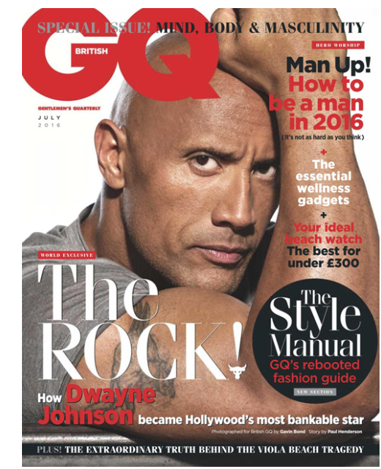

Examples of the varied representations of ethnicity

Examples of varied representations of men

Examples of the varied representations of ethnicity

Examples of varied representations of men

Representation Theory

David Gauntlett Identity Theory

Stuart Hall Representation Theory

* The media now represent groups of people in various ways
* If there are not varied representations then the hegemonic ideology will continue to be reinforced
* The media often use stereotypes
* Stereotypes reduce people into negative oversimplified clichés