SPECTRE
Spectre is a James Bond film released on 26 October 2015, starring Daniel Craig as 007 in his fourth performance as the fictional MI6 agent.

Based on a book by Ian Fleming, the film was produced by the British company Eon (Everything or Nothing) Productions and distributed by United Artists.

The film was created with an estimated $245 million budget making it the most expensive Bond film and one of the most expensive films ever made. It grossed over $880 million at the worldwide box office.

The poster was designed by Empire Designs, a British film promotion agency. The poster was released on 3 September 2015, as part of a wide global marketing campaign for the film.

The Man with the Golden Gun
The Man with the Golden Gun is a James Bond film released on 19 December 1974, starring Roger Moore as 007. This was only Moore’s second appearance as the fictional MI6 agent.

Based on a book of the same name, written by Ian Fleming, the film was produced by the British company Eon (Everything or Nothing) Productions and distributed by United Artists. The film was created with an estimated $7 million budget and grossed over $97 million at the world wide box office.

To reflect the popularity of the Martial Arts film genre, with the rise of stars such as Bruce Lee and Jackie Chan, there were several Kung Fu scenes and the film was filmed predominantly in Asia, having being shot in Hong Kong, Thailand and Macau.

The artwork for poster itself was produced by artist and illustrator Robert McGinnis.

Historical/Cultural Context – The Man with the Golden Gun
This was when the oil producing Arab nations proclaimed an oil embargo (ban on trade) causing an oil crisis which had both short and long – term effects across politics and the economy for several countries across the globe.
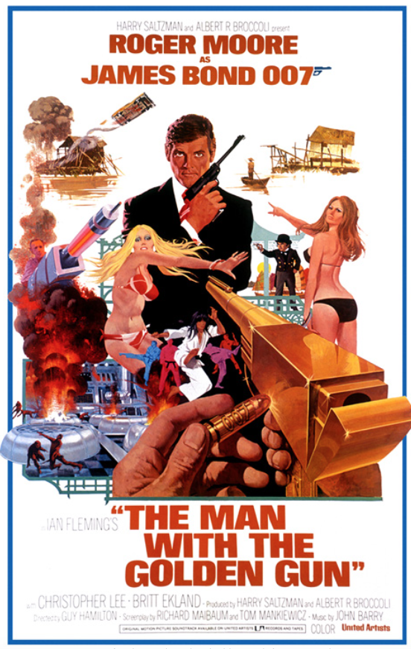
Which part of the poster suggests a link to the 1973 energy crisis?

What does the image suggest?

Historical/Cultural Context – Spectre
It is a festival in Mexico celebrated on 2nd November focusing on remembering friends and family members who have died. It did not include a parade until after Spectre came out.
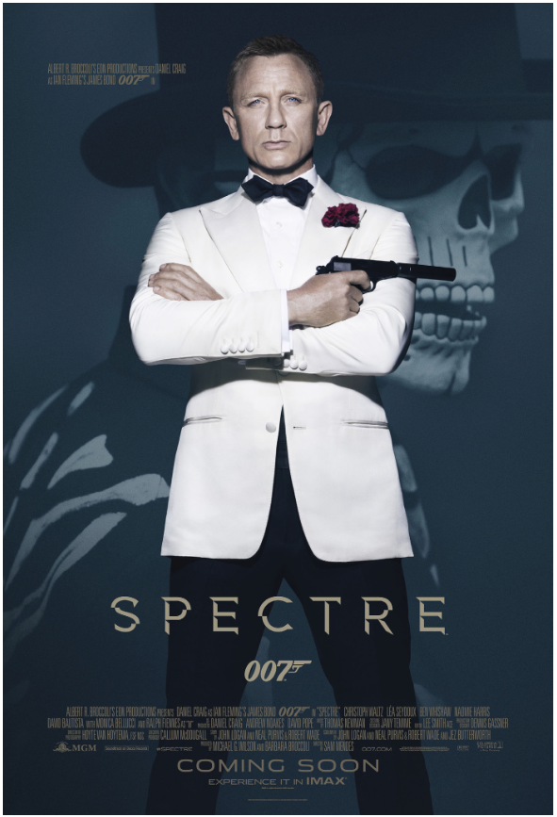
Which part of the poster suggests a link to the Mexican Festival ‘Day of the Dead?’

Why is this featured on the poster?

