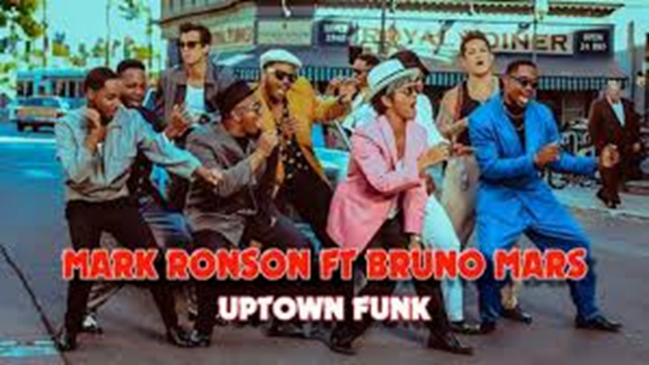

**Genre**

Duran Duran – Rio falls under the “Performance” genre. List some examples of the genre’s conventions being conformed to specifically from the video itself. It could also be argued to follow some “Narrative” conventions.

Performance:



Narrative:



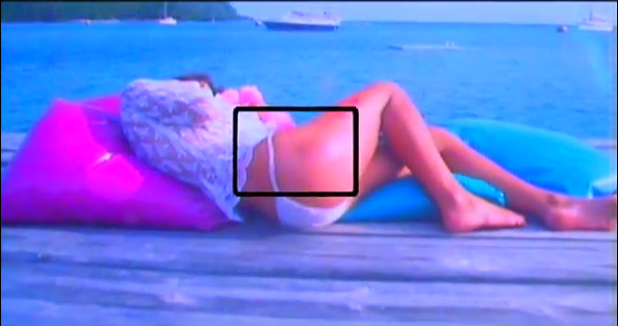**Media Language & Representation Analysis**

*Make denotative and connotative comments:*

*How has gender been represented in this shot?*

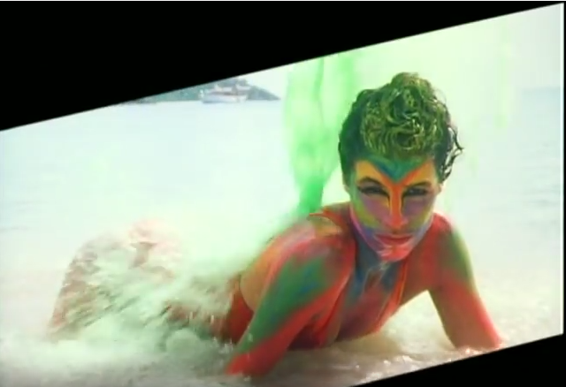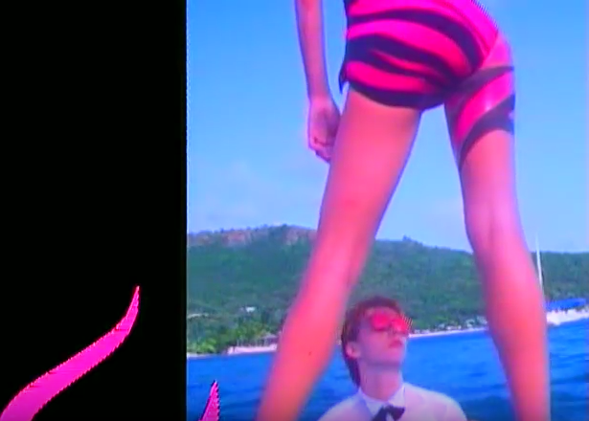

*Make denotative and connotative comments*

*How has gender been represented in this shot?*

*Make denotative and connotative comments*

*How has gender been represented in this shot?*

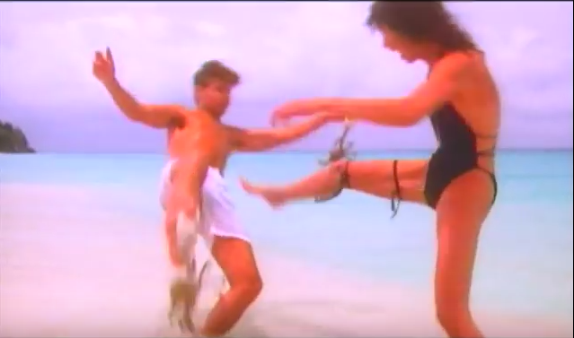

*Make denotative and connotative comments:*

*How has gender been represented in this shot?*

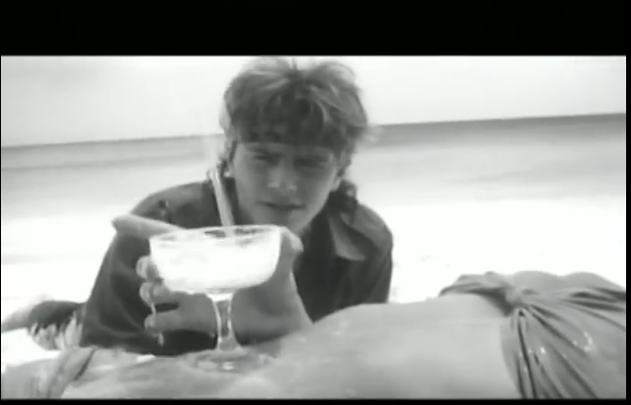

*Make denotative and connotative comments*

*How has gender been represented in this shot?*

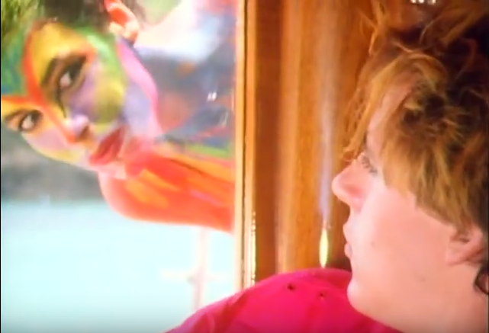

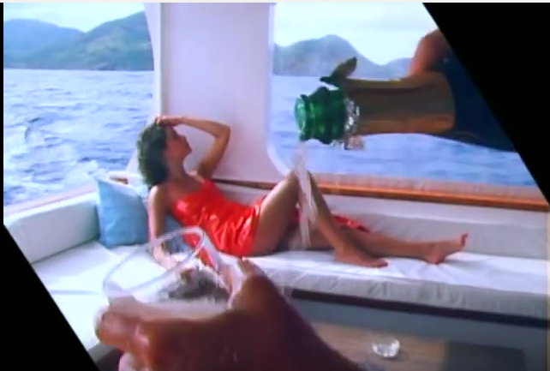

*Make denotative and connotative comments*

*How has gender been represented in this shot?*

*Make denotative and connotative comments*

*How has gender been represented in this shot?*

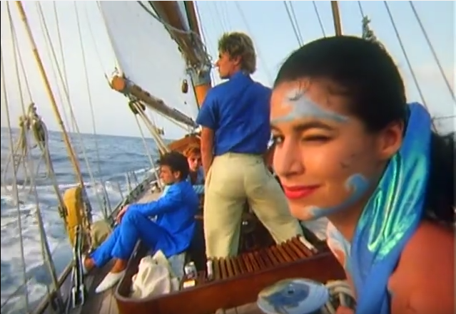

*Make denotative and connotative comments*

*How has gender been represented in this shot?*