**GCSE Media Studies – Set Product Fact Sheet**

**Component 1: Exploring the Media**

Focus areas:

* Media Contexts
* Media Industries
* Audiences

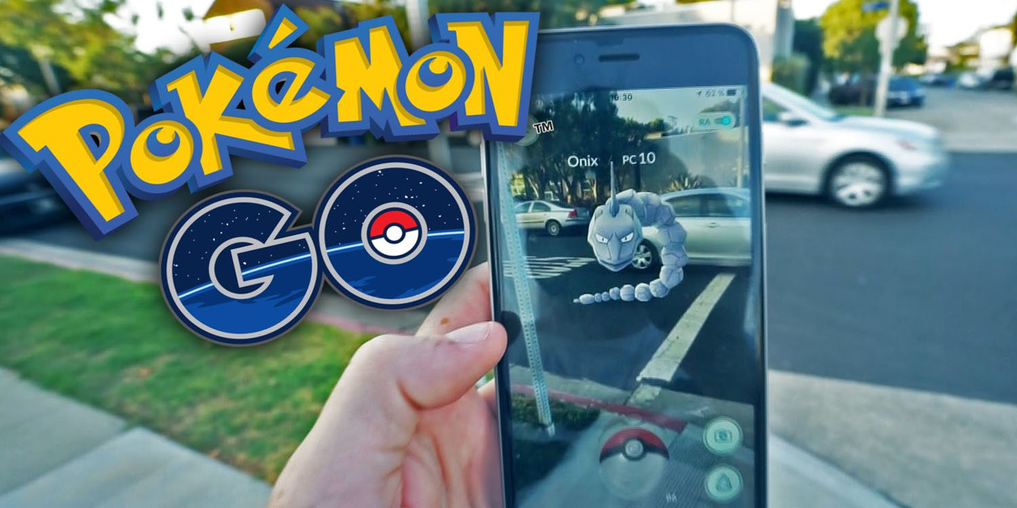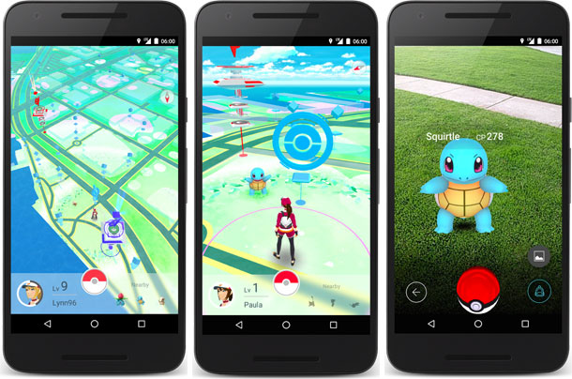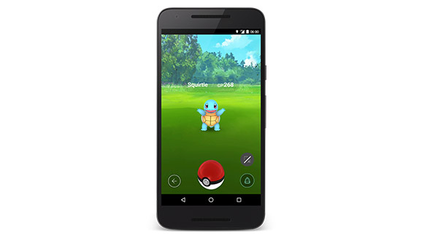 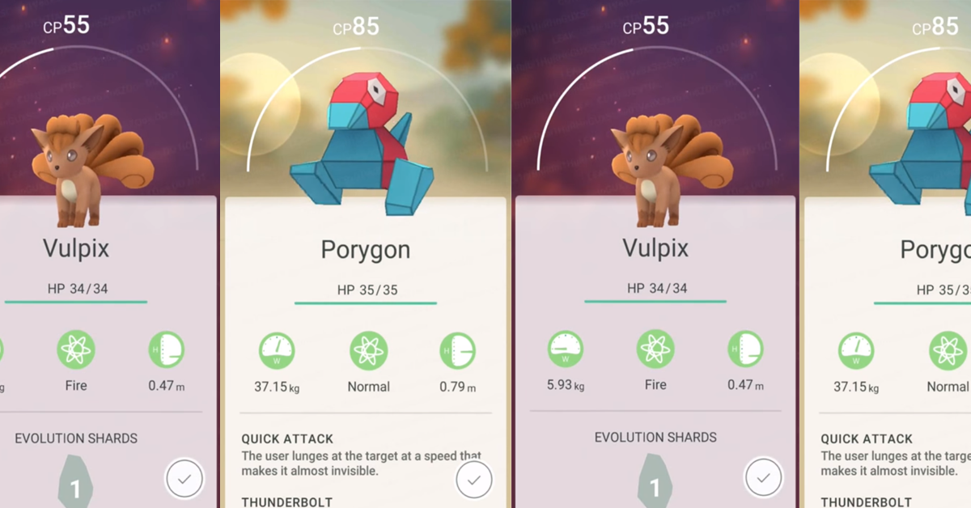

Video Games

* Pokémon Go 2016

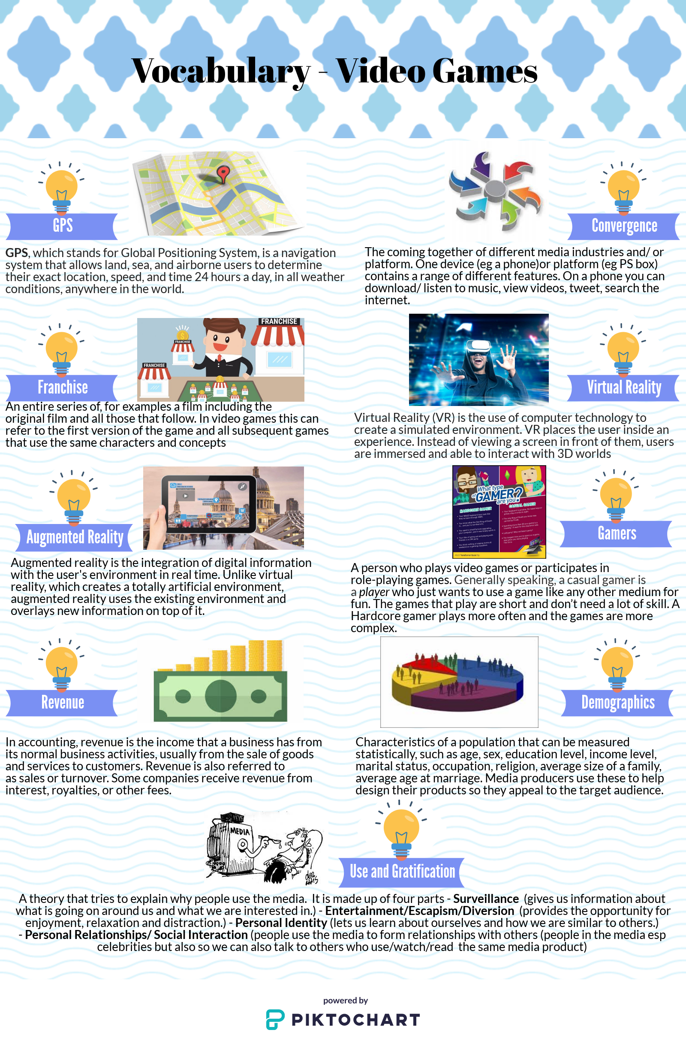

**Production Context**

**Key information about Pokémon Go**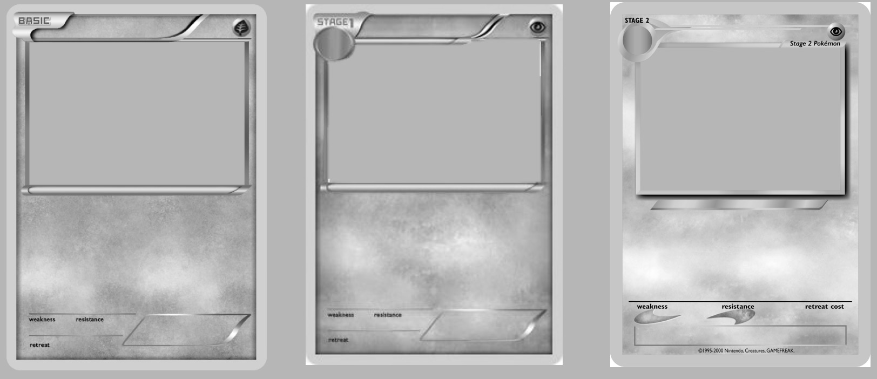

**Cultural Context**

**The Pokémon World**

**Pokémon Go (2016)**

**The Video Game Industry**

Funding

Revenue

Regulations:

Franchise

Technology & Convergence:

**Pokémon Go (2016)**

**Audiences**

Target audience:

Explain what demographics are in your own words

Who was the original target audience for Pokémon Go?

Who is now the target audience of Pokémon Go?

Why is it important that you know who your target audience is?

Use and Gratification Theory:

Social and Cultural Issues: