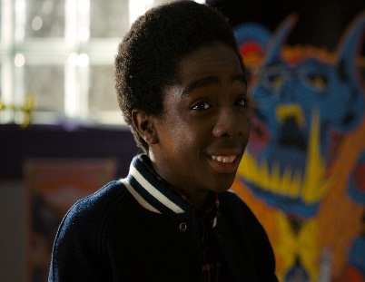

**Lucas Sinclair**

**12 years old**

**African-American**

**DIALOGUE/NARRATIVE ANALYSIS**

**MISE-EN-SCENE ANALYSIS**

**REPRESENTATION ANALYSIS**