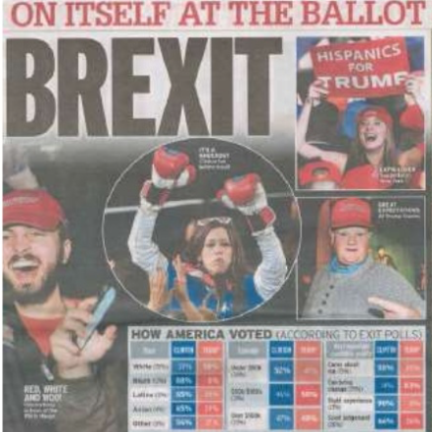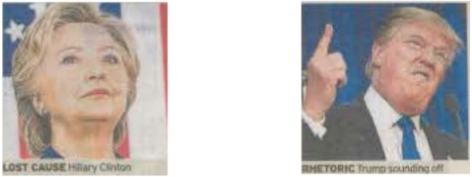 

I can explain how representations invoke discourses and ideologies and position audiences

I can apply Hall’s theory of representation to the text

I can identify how audience responses to and interpretations of media representations reflect social, cultural and historical circumstances

I can apply Gauntlett’s theory of representation to the text

Representation