Conventions of a fashion/lifestyle magazine:
- Celebrity endorsement
- Current trends featured
- Tips for fitness, beauty etc.
- Informal, relaxed language
- Direct mode of address
- Social media promotions
- ”How to wear features”
- Mid Close Up and Long Shots
- High street fashion
- Women and men portrayed as sexual objects.

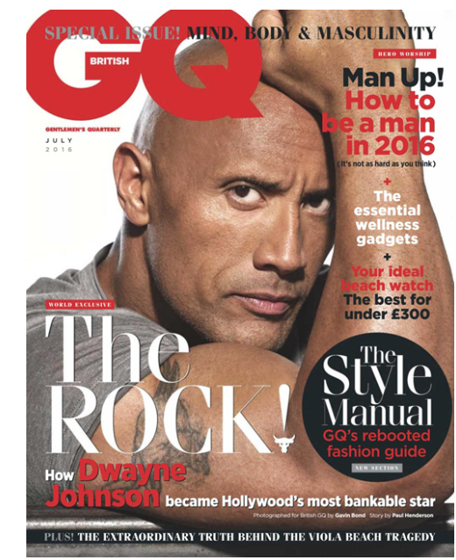
Identify the conventions on our set texts below!

