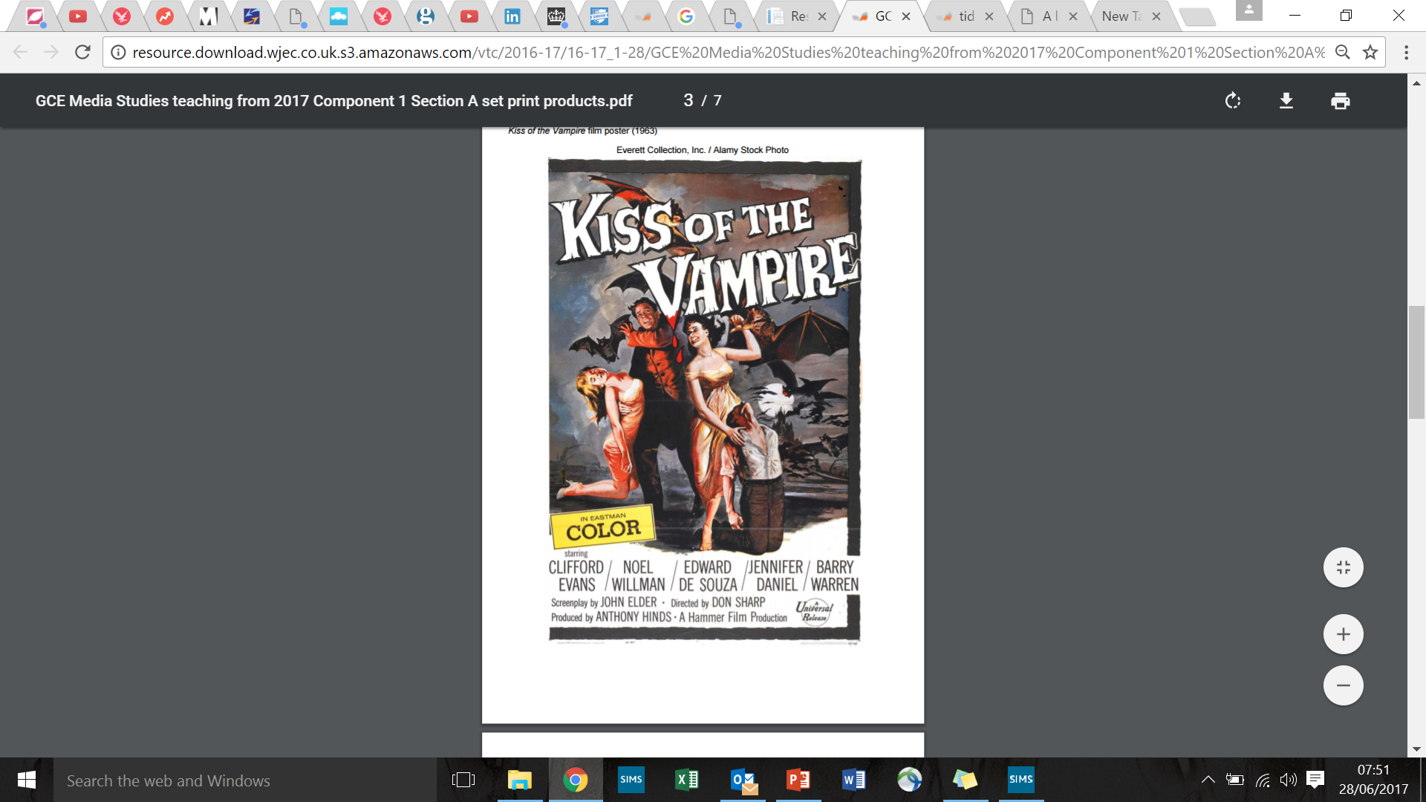

Apply Van Zoonens Theory

Apply Stuart Halls Theory

Are gender stereotypes being reinforced or challenged?

Are the representations empowering or disempowering? Explain.

Are there groups of people that are being misrepresented?

Are there groups of people being under-represented?

\

What values, attitudes and beliefs are conveyed?

How will the audience respond?

What are the negative representations?

What are the positive representations?