

The writing on the poster is written in a bold and golden font. *What connotations has gold got? Why write it in bold font?*

The poster uses the rule of thirds. At the top third is the credits for Albert R Brocolli and Harry Stalzman. This was to be the last time that the two men co-directed a Bond film together. *Why would these names be at the top of the poster?*

Extension Task: Try to identify all of the “Bond” iconic conventions within the poster.

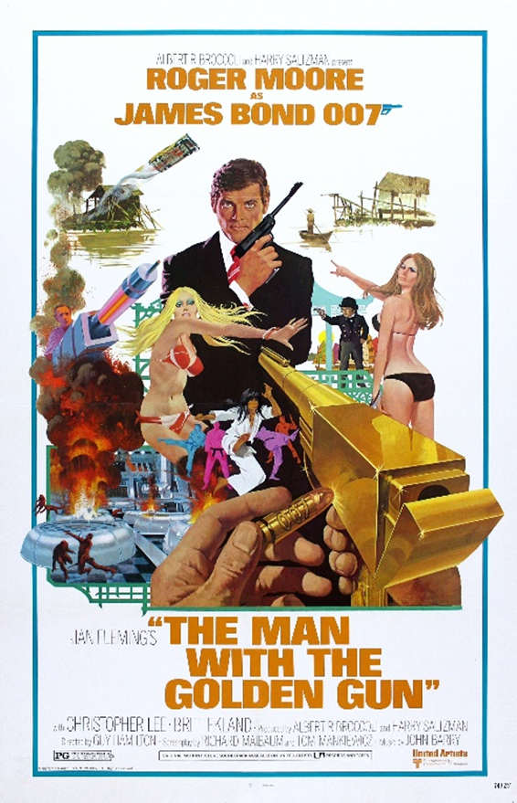

There is a man at the top of a huge explosion manning a giant laser beam that is pointed towards the protagonist (James Bond). *Which Propps character types does this man seem to be playing? Why? What connotations are found here?*

James Bond’s facial expression is calm and collected but serious in it’s tone.

James Bond is in the centre of the poster, surrounded by women and all of the action that seems to be unfolding. *What character type must he be? Why?*

There are small bamboo huts either side of a river. There is a man in a small boat, and a car that is mid jump from an exploded hut, trying to reach the second hut across the river. *What does this suggest about the narrative of the film? How is the car and the explosion conventional of the genre?*

The 007 logo features twice on the poster. The logo’s 7 is designed to look like a gun.

There is a man holding a golden gun. He seems to be loading it with a bullet that has the inscription “007” on it. *What does this suggest about the narrative of the film? What could the colour gold suggest about the gun (other than wealth)?* *What could it mean for James Bond?*

The centre third of the poster is taken up by the main image. The main image has a lot of masculine things within, such as women in bikinis, cars and guns. *What does this suggest about the storyline? Why would the main image be so jam packed with action? How does this link to the genre of the film?*

There are women wearing bikinis. One of the women is pointing at Bond, whereas another woman seems to be shielding Bond from the gun. *What viewpoints on gender are being created here? What do the bikinis suggest?*

There are several male names on the poster including Roger Moore (James Bond actor), Christopher Flemings (author of the book) Christopher Lee (actor) and many more. *What does this suggest? How might this link to the historical patriarchal context?*

The title of the film “The Man with the Golden Gun” is written in quotation marks. *What could this suggest?*