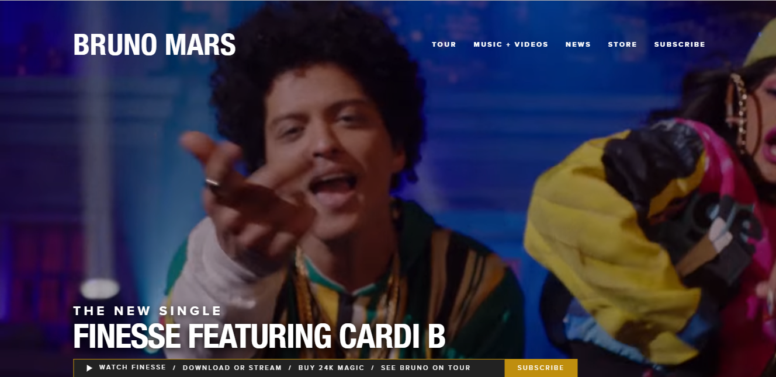
The first thing is seen on the landing (home) page is an audio-free snippet of Bruno Mar’s new song. How does this promote him as an artist in a way that inspires his audience?

The name of the artist, the tabs and the name of the new single is written in a white, bold, sans-serif typography. Why do you think the producers chose this colour scheme?

How do the characters in the video match Mar’s energetic, urban and retro style?

Why has a simplistic layout been used? Where does it draw the audience’s attention to?

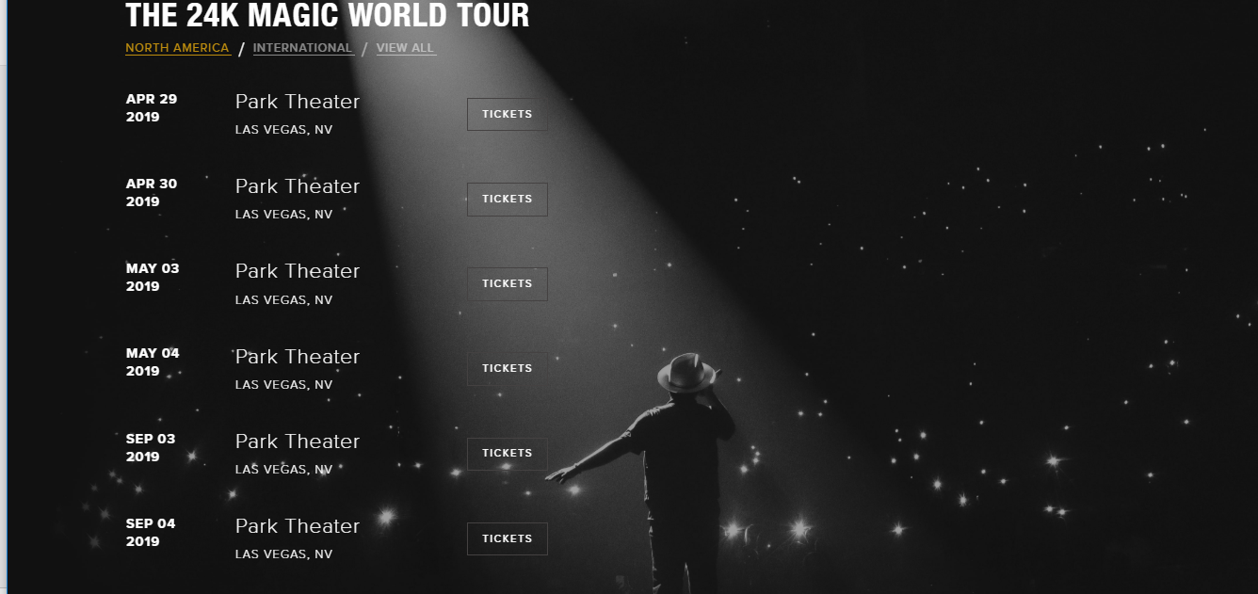
After scrolling down the second part of the homepage is info of Bruno Mar’s tour. How has the image been used to promote the tour to the audience?

At the time of visiting the page, Bruno Mars was advertising for his Las Vegas dates. What does it suggest the fact that he can sell out a popular stadium in Vegas multiple times suggest about him as an artist? Why Vegas?

What tone does this part of the website have and who would this appeal to?

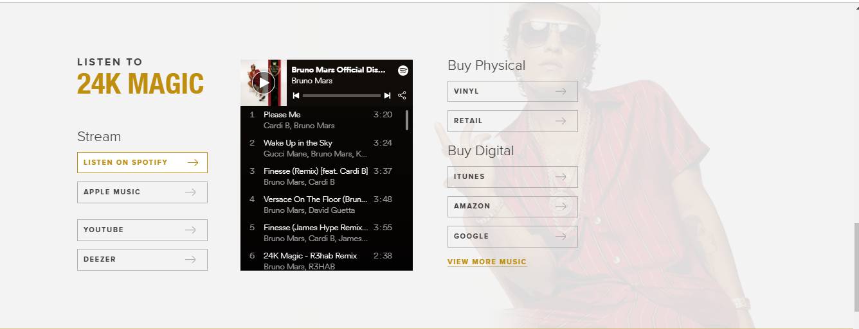
The website offers fans a chance to purchase the latest album. Users can choose between streaming on various platforms, downloading digital copies or purchasing physical copies (CD/Vinyl).
How does this fit Bruno Mar’s style?

How does this appeal to a wider audience?

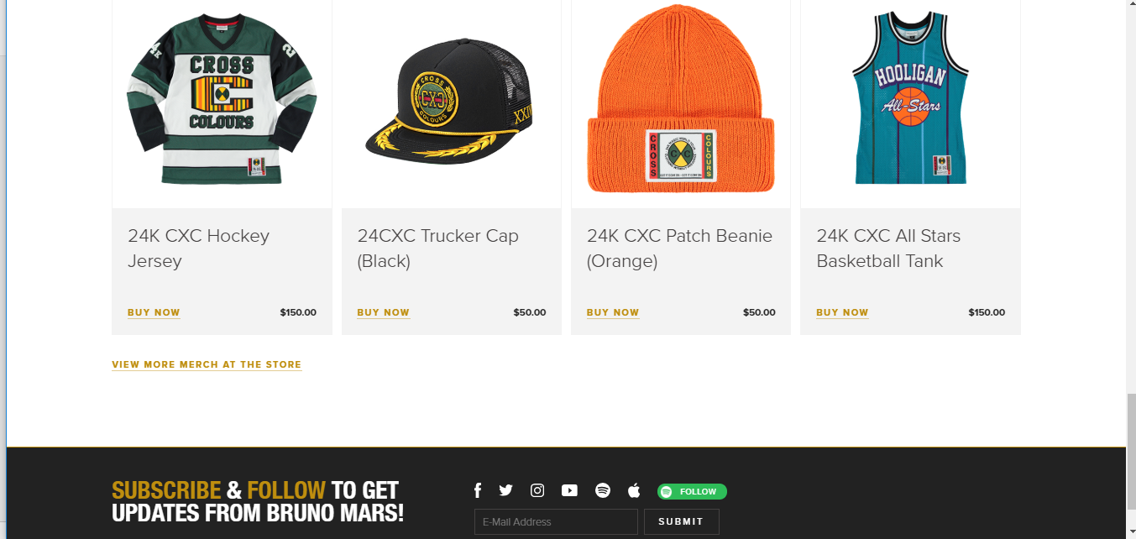
How does the merchandise on offer to the audience match the music video featured at the top of the homepage? Why would they have done this?

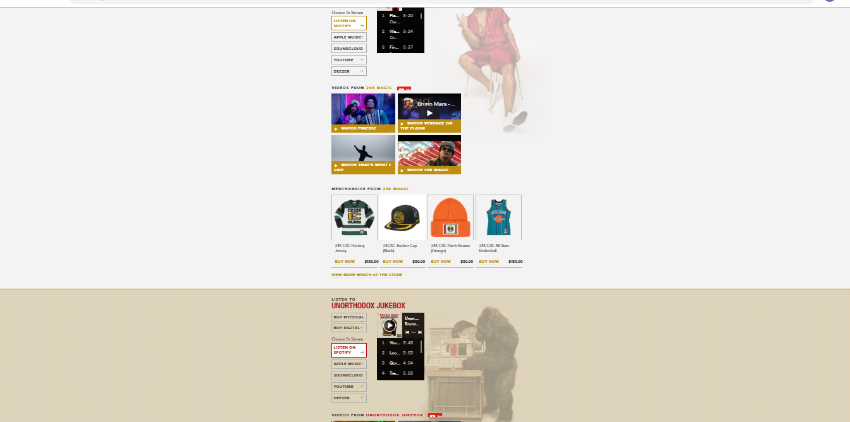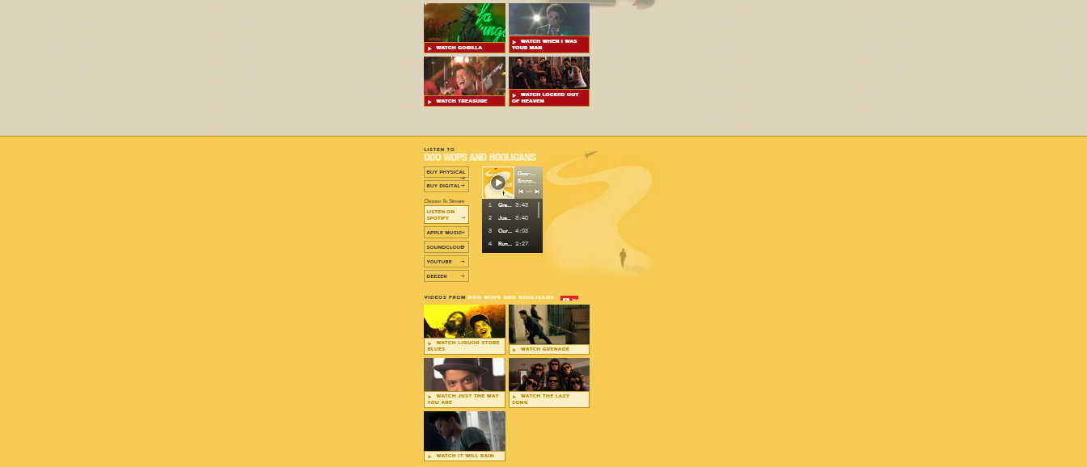
There is a “Music + Videos” page which features previous albums of Bruno Mars.

Why would Bruno include various popular music videos on this page?

What are the advantages of synergising his new album with the website and his other creative material?

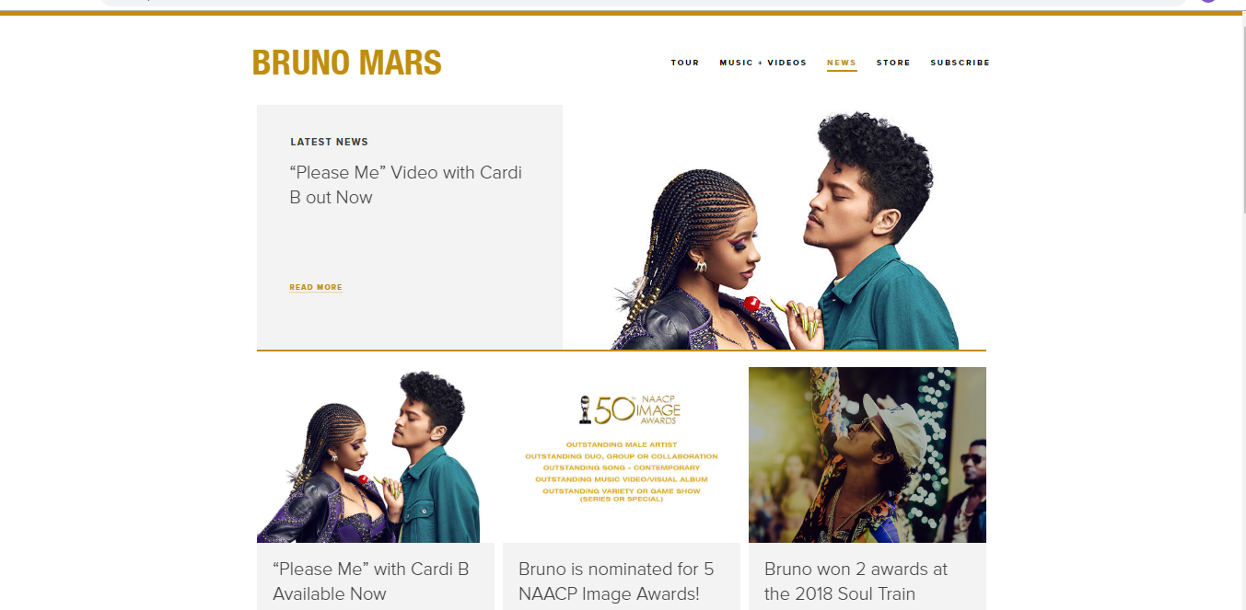
The colour scheme is gold and white. Why have these two colour been featured on the “News” page?

In the image at the top of this page Bruno Mars is standing very closely to Cardi B. What does this suggest about their relationship? Why would they bring this to the attention of the audience?

Bruno was nominated for 5 NAACP awards (National Association of the Advancement for Coloured People). Why would this be a big deal? What does it suggest about him as an artist?

By pressing the link, audiences can see many more pictures of Katy Perry taken mainly from her music videos. Which of the uses and gratifications does this give audiences and why?

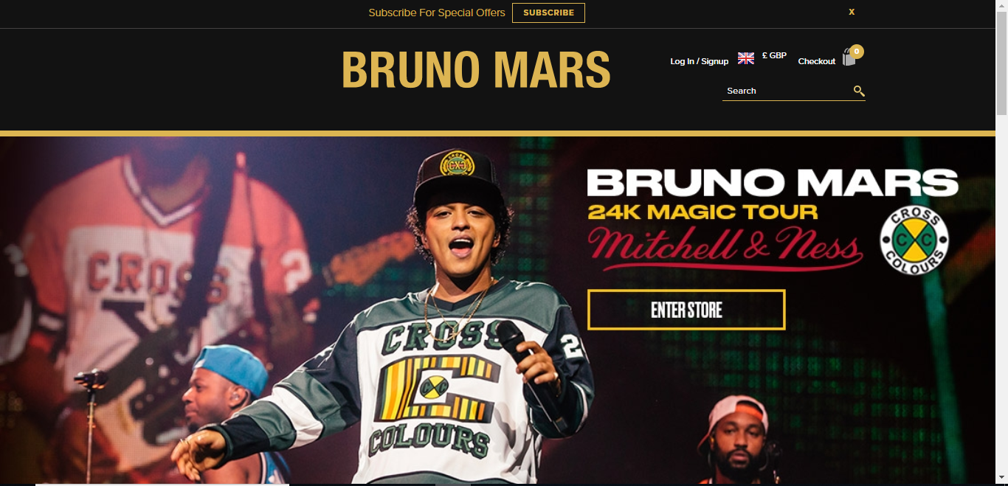
When the audience clicks on the “Store” tab on Bruno’s main page, they are taken to a separate page called “warnerartist”. What does Bruno having a separate website for merchandise – and his own merchandise chain – suggest about his style?

The store and the main page features a variety of ethnicities – however black (African-American) people take up the majority. Why would this be the case?

Social Media – Bruno Mars

How many followers does Bruno Mars have on each of his social media accounts?
- Twitter
- Facebook
- Instagram
- Youtube
What does he post on the social media platforms?

How are the platforms used similarly as each other?

How are the platforms used differently?

Challenge! IF YOU CAN GET BRUNO MARS TO REPLY/SHARE/LIKE YOUR COMMENTS ON ANY OF HIS SOCIAL MEDIA ACCOUNTS – I WILL BUY YOU A BIG BAR OF CHOCOLATE!

