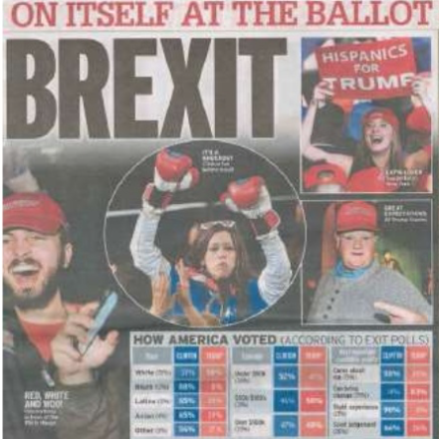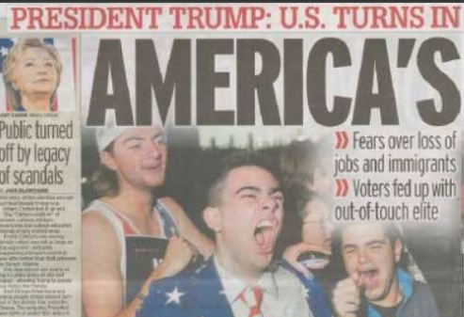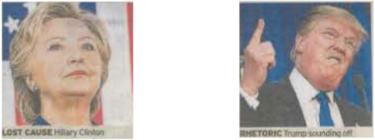 

I can explain how representations invoke discourses and ideologies and position audiences

I can identify the way events, issues, individuals and social groups are represented through the process of selection and combination

I can analyse the way in which media constructs **versions of reality** through re-presentation

I can identify how media representations convey values, attitudes and beliefs about the world and how these may be systematically reinforced across a wide range of media representations

I can identify the processes which lead media producers to make choices about how to represent events, issues, individuals and social groups

I can analyse the effect of social and cultural context on representation

I can explain how audiences respond to and interpret media representations

I can explain how and why particular social groups, in a national and global context may be under-represented or misrepresented

I can identify how and why stereotypes can be used positively and negatively

Representation