Social and Cultural Significance of Representations
The campaign’s agenda is to encourage women to participate in physical activities by challenging dominant ideology. Stereotypically, women have often been thought of as the weaker sex and often less successful, particularly where sport is concerned.
Task
Consider the ideologies surrounding the sports and people that you see below.
1. Are they manly, or feminine, or neutral?
2. Why would they be considered this way? What type of rules, conduct and skills are featured in the sport?

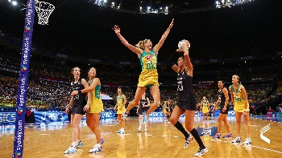
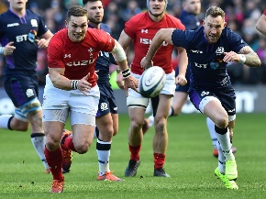
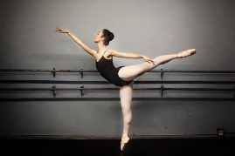
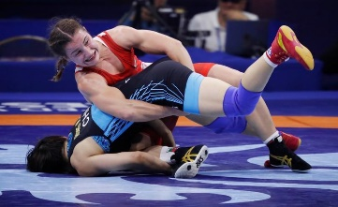
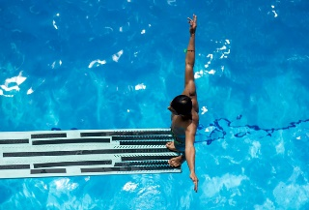
Overall summary
What is expected from “manly” sports?

What is expected from “girly” sports?

Extension Task: Link the sports above to stereotypes of “masculine men” and “Feminine women”.

Task
How do the two images relate to stereotypes?
Do they conform to any stereotypes or dominant ideologies? OR do they subvert any stereotypes or dominant ideologies?
Explain using evidence.

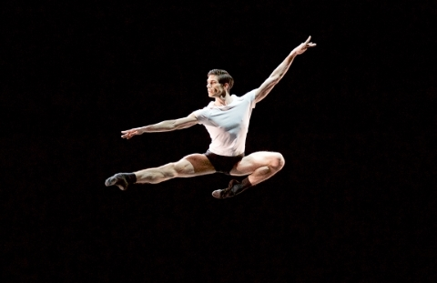
Explain how this male ballerina conforms to masculine stereotypes.

Explain how this male ballerina subverts masculine stereotypes.

Link to social context:

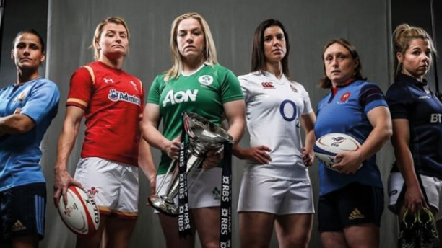
Explain how these female rugby players conforms to feminine stereotypes.

Explain how these female rugby players subvert female stereotypes.

Link to social context:

