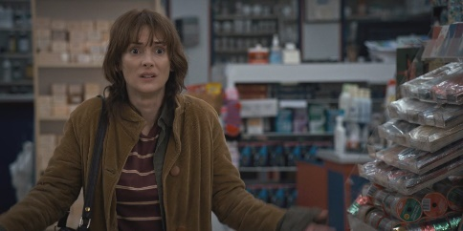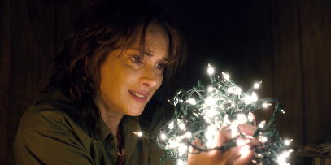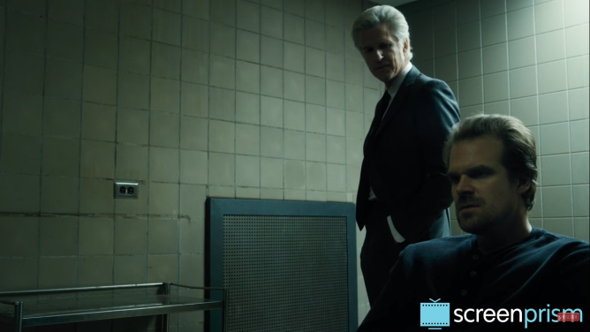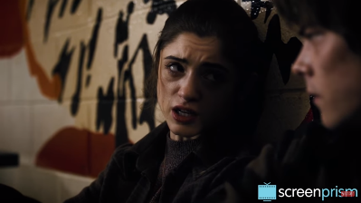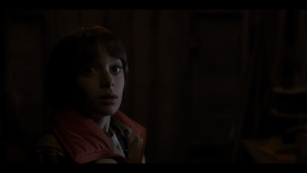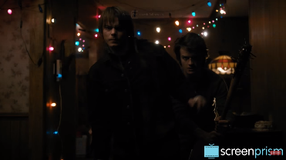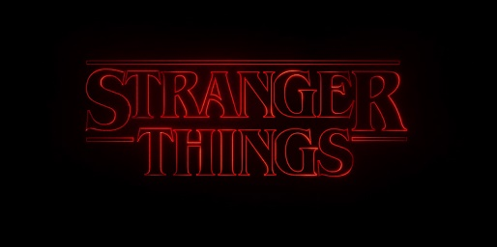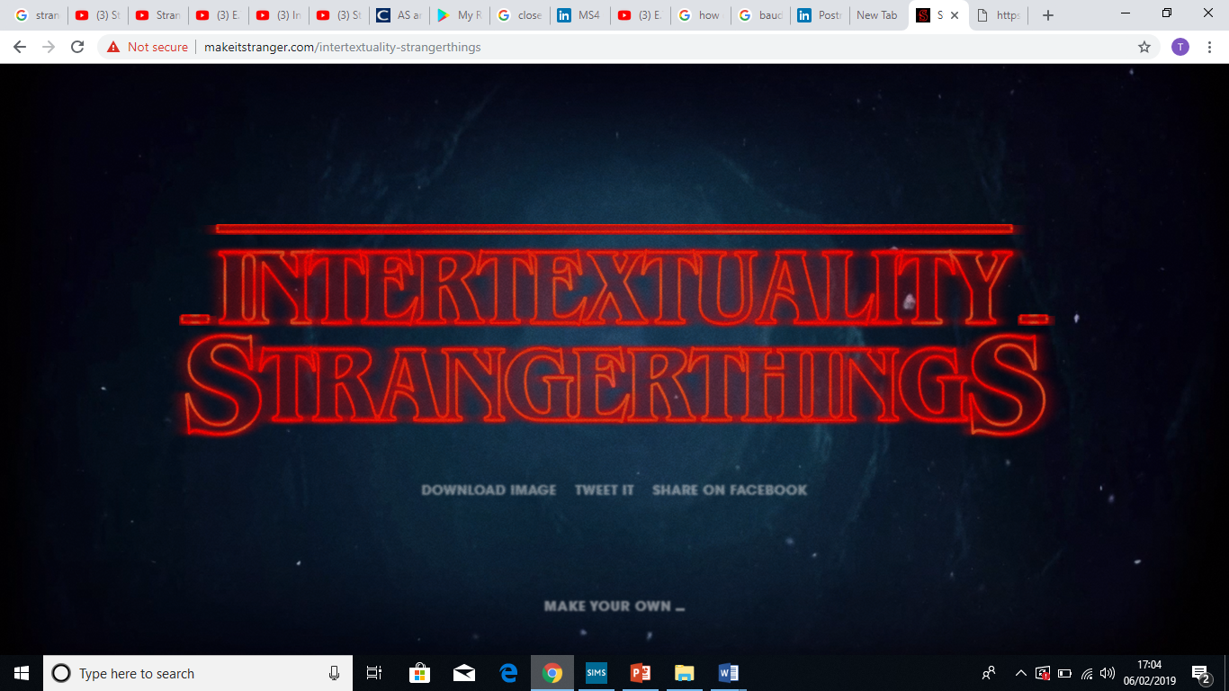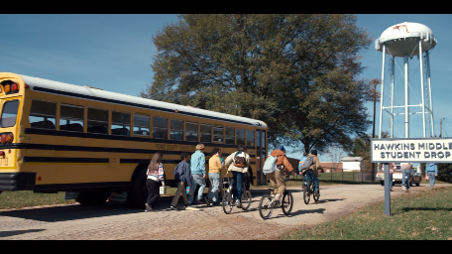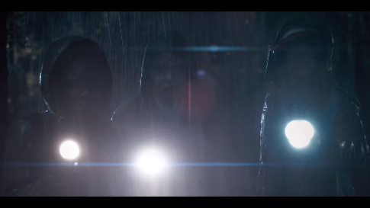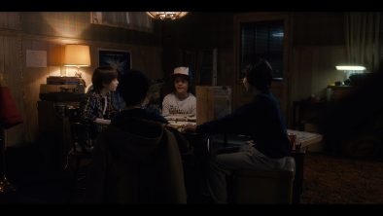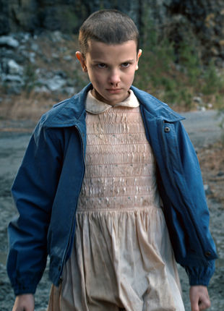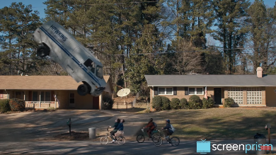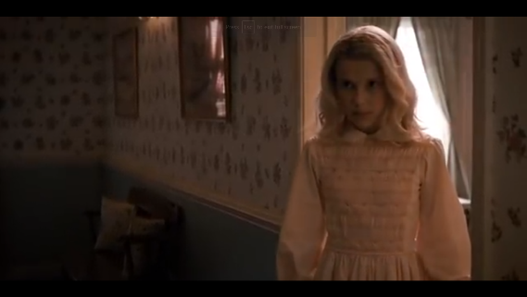

Hopper being driven to help Will as a result of his fatherly love, to make up for the loss of his daughter is an intertextual reference to…

Joyce becoming obsessed and not being taken seriously…

Joyce using lights to communicate with Will

Hopper has to fight a higher authority to protect his community…

Nancy wanting to kill the Demogorgon herself is an intertextual reference to….

The monster is seemingly able to appear from nowhere….

Nancy realising that the Demogorgon is attracted to blood is an intertextual reference to…

The teens lure the monster a booby-trapped house and think that they have beaten it…

**General/Other – intertextual References**

Typography inspired by...

Soundtrack inspired by…

Stranger Things title sequence

This is one way in which cultural and historical contexts can influence a product…

The boys being a close group of friends that ride their bikes and play games together is an intertextual reference to…

The boys finding an outsider who is hiding from a secret agency is an intertextual reference to…

The scene where the audience are first introduced to the boys is an intertextual reference to…

11 and the boys not knowing if her and her powers are good or bad is an intertextual reference to…

11 is being chased by secret government officials is an intertextual reference to…

The boys disguise 11 is an intertextual reference to…

**The Boys – intertextual References**

**Eleven – Intertextual References**