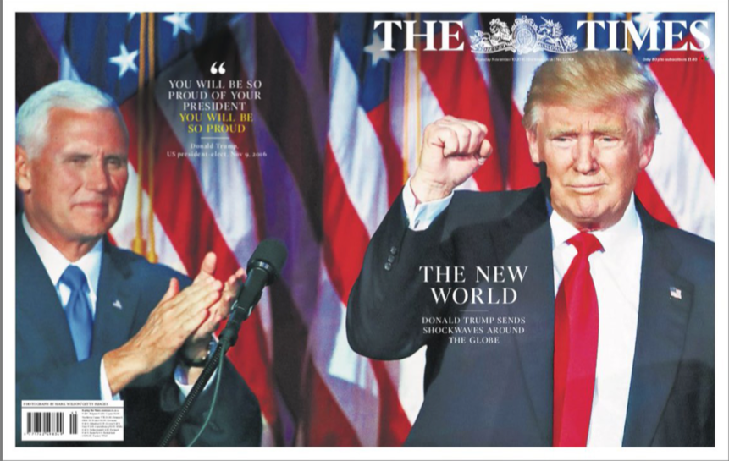

**Code of dress**

**Body language**

**Audience response**

**Copy**

**viewpoints**

**MY observations**

**Theoretical approaches**

**Mode of address**

**American iconography**

**Cultural context**