The people behind the This Girl Can campaign aimed to inspire women to overcome the stereotypes of exercise and sport by constructing a very positive representation for all women to aspire towards.
They did this by:
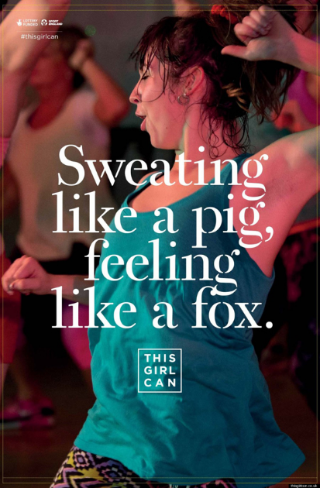
- Selecting specific images,
Media Language Codes
- Happy Facial Expression
- Candid photograph (taken mid motion)
- Long shot of body exercising
- Colourful clothing
- Loose clothing
- Sweaty hair and no makeup
- Mantra “sweating like a pig, feeling like a fox”
- Campaign name “This Girl Can”
- Lots of women in the background
- Woman in the foreground central position
Task
Explain how women are being represented through the use of combined codes of media language.

Write 2 paragraphs that use the PEDAL Structure (Point/Evidence/Discuss/Alternative POV/Link (context/theory)
Representation Analytical Terms
- Stereotypical
- Conforms/Reinforces
- Subvert/Challenges
- Represented as..
- Suggests, infers, signifies, connotes

Representation prompts
- Carefree
- Dominant
- Strong/strength
- Inclusive
- Realistic
- Rawness
- Determined
Model Paragraph
(Point)The campaigners have represented women as determined to get fitter. (Evidence)This has been constructed with the use of the reddish glow to her skin caused by the light in combination with the candid photo of her exercising.(Discuss)The reddish glow suggests that she is really hot as she has been working out a lot. This subverts stereotypical representations of women seemingly put their beauty before being hot and bothered. (Alternative POV) Althernatively the reddish glow could represent a disco light and could suggest that the women are having fun exercising. (Link Theory) Stuart Hall would argue that as this advertisement is made with women in mind, the break in stereotypes is to be expected.
- fonts, colours and words
- Combining them together
- Deciding (mediating) what “combination” best to fits the message of “all women can exercise no matter what”.

Write your paragraphs here

