Age ratings are systems used to ensure that entertainment content, such as computer games, are clearly labelled by age according to the content they contain. Age ratings provide guidance to consumers (particularly parents) to help them decide whether or not to buy a particular product. The rating on a game confirms that it is suitable for players over a certain age.
1. What does stand for?

2. Circle the age rating that Pokemon GO! receive in the UK.
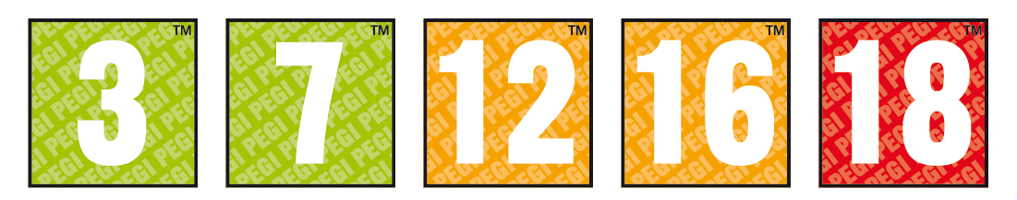

3. What are the key differences between a 3 and a 7 game?

4. What do each of these symbols mean?

5. Apply the following symbols to the gameplay and features of Pokemon Go!

