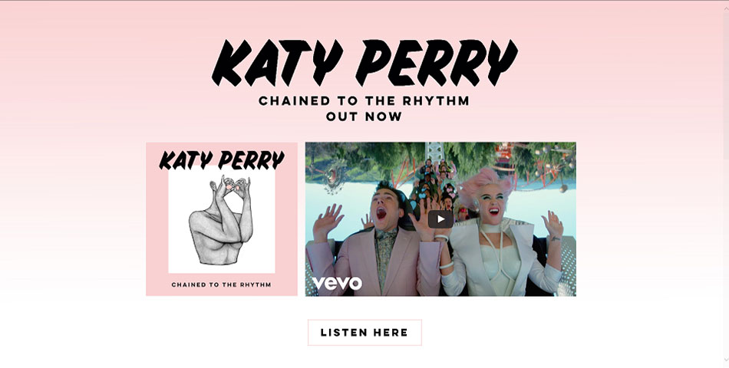
How is the landing (home) page used to promote Katy Perry?

How is the colour scheme used effectively?

How do the characters in the video match Perry’s style of being ‘fun’ and ‘camp’?

Why has a simplistic layout been used? Where does it draw the audience’s attention to?

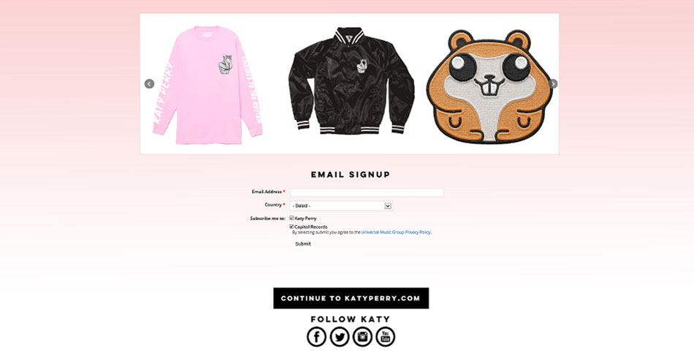

What are the benefits of having a separate “Featured Merch Items” section on the landing page? Consider the audience, revenue and artist image.

What does the abbreviation of the word merchandise into “Merch” suggest about the target audience?

The space at the bottom of the screenshot shows social media links to Perry’s pages. Why have these been included?

There is also a link for audiences to use to “subscribe”. What type of audience may do this?
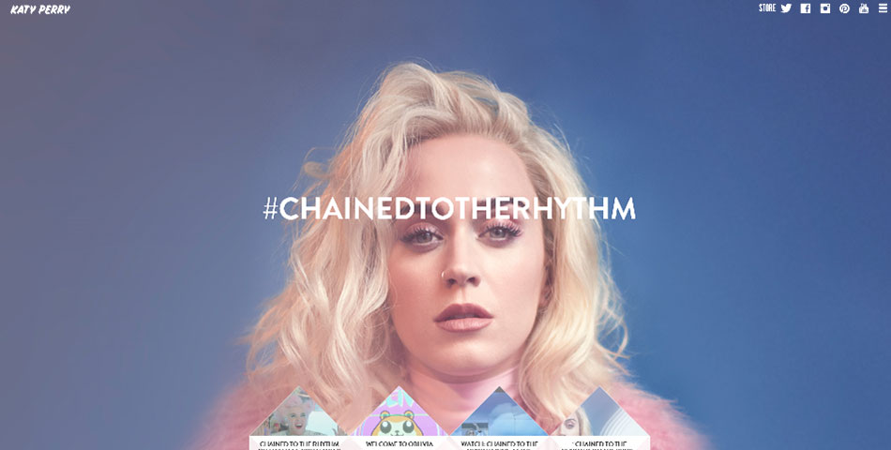
This page includes a close up of the artist appearing to be gazing directly at the audience. What effect does this have?

Why has a dominant central image with sparsely anything else on the page been used?

How has Perry’s brand identity been reinforced on this page? Consider social media, style, colour and mise-en-scene.

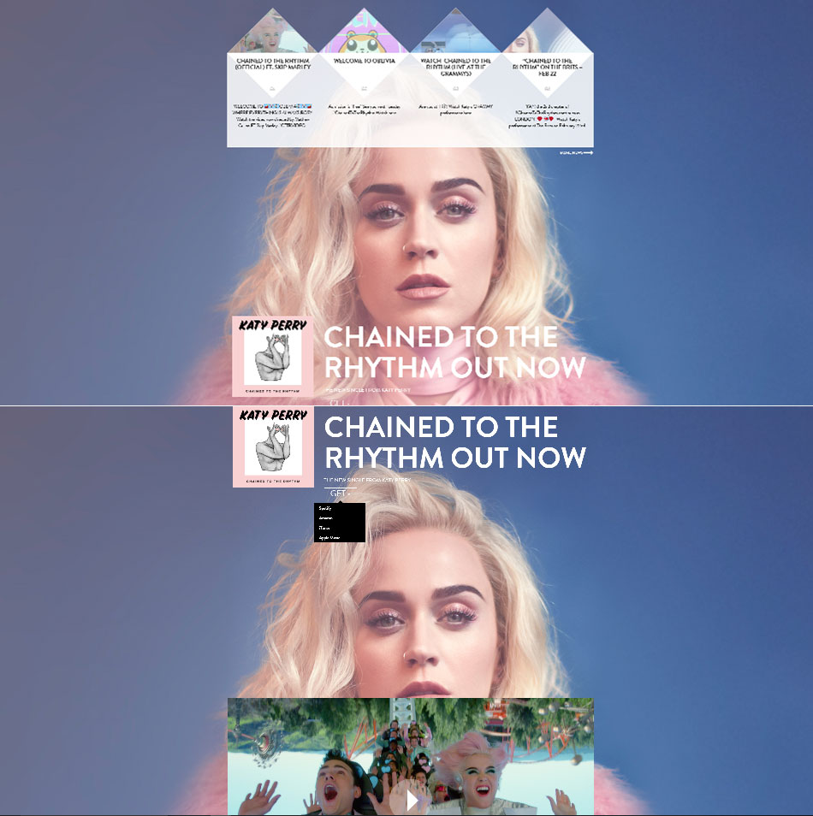
As the audience scroll down, the dominant image remains static whilst the other information is laid over the top. Why has this been done?

There are four videos which are all linked to the new single (the actual video and another promotional video, along with two different award ceremonies). Why have these four videos been linked together?

Just under the single there is a ‘Get it’ call to action button which offers a drop down menu of music retailers. Why has this feature been included right underneath the video?

Why is including the music video, a link to the song and the use of the website an example of synergy?

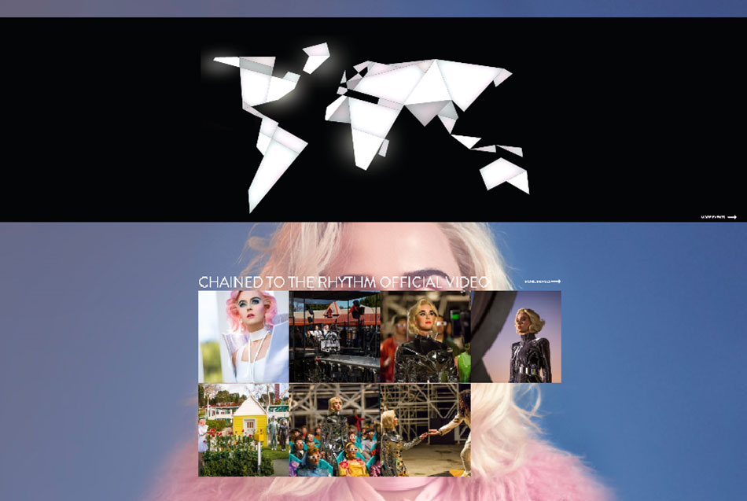
What does the use of geometric map in the form of a link to her ‘events’ page imply about Katy Perry’s reputation?

There are more images taken from the single’s music video. Why?

By pressing the link, audiences can see many more pictures of Katy Perry taken mainly from her music videos. Which of the uses and gratifications does this give audiences and why?

The gallery of images shows all the different looks/personalities the artist has displayed through her different videos. For example, the more futuristic look of Chained to the Rhythm, to the sexualised images of ‘I kissed a girl’. What reasons may this have been done for?
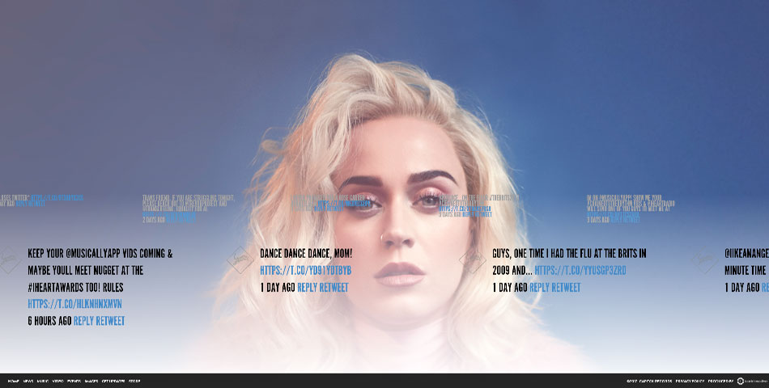

How has the website been set up for a younger audience? Consider interactivity, synergy, colour and social media.

At the very base of the page is the website navigation, taking you to all the pages. There is also the industry information such as her record label, which is also a clickable link to their website. Why?

Complete the table below on the advantages and disadvantages of different social media platforms.
 | Advantages | Disadvantages
Facebook
Twitter
Instagram
YouTube

How many followers does Katy Perry have on each of her social media accounts?
- Twitter
- Facebook
- Instagram
- Youtube

Despite Katy Perry having over 100,000,000 followers on Twitter, she only follows 198 people. Why do you think that is?

What does she post on the social media platforms?

How are the platforms used similarly as each other?

How are the platforms used differently?

