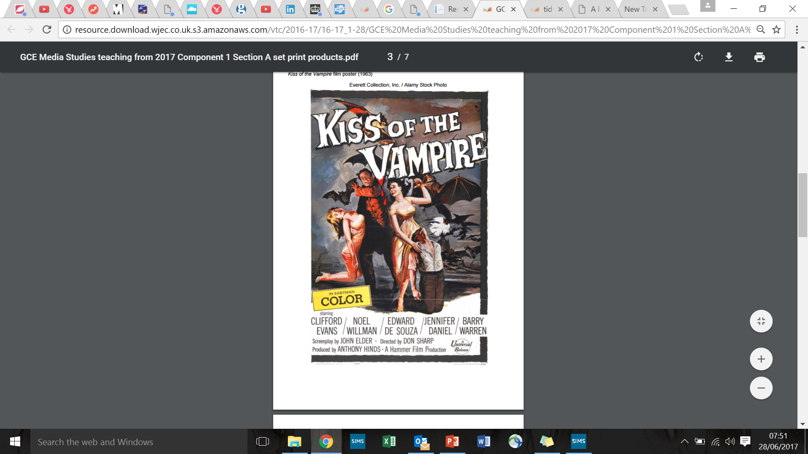

Group 4: Characters and Narrative

As well as your own ideas, consider the following…

The use of a ‘painted’ main image is highly conventional of films of the period. Look up the film poster for Christopher Lee’s *Dracula,* can you discuss intertextuality in relation to this?

How are the Symbolic Codes (Barthes) of horror, darkness and fear reinforced?

Consider Propp’s characters theory and stereotypical gender roles.

Consider Roland Barthes’ Semeiotics…how is suspense and enigma created and what is the effect? *,*

Group 3: Use of layout features (composition of images, graphics, positioning, font & typography)

As well as your own ideas, consider the following….

What are the connotations of the capitalised, serif font?

What is signified by the ‘wooden’ styling and the blood dripping from the letter V’s ‘fang’ – could you link this to the genre of the product?

Very conventionally the ‘stars’ of the film are listed with the more highly paid male actors first and in order of fame, (Clifford Evans having starred in Hammers’ 1961 hit *Curse* *of the Werewolf)* why is this the case? (think contexts)

Consider Barthes’ Semantic Code in relation to the images of the bats.

Group 2: Use of language

As well as your own ideas, consider the following…

Consider Strauss’ theory of Structuralism: The idea that texts are constructed through the use of binary oppositions and consider the juxtapositions created between “kiss” and “vampire”.

Consider Roland Barthes’ theory of Semiotics…how are suspense and enigma created and what is the effect?

Group 1: Use of colour

As well as your own ideas, consider the following…

What does the gloomy grey, black and brown colour palette reinforce about the genre?

How are the film’s dark, scary conventions connoted to the audience through other colours

What does the colour red highlight?

The use of yellow in the credit block is unusual – why has this been used here?  Also consider technological advancements here and what this suggests about the narrative.