Additional reading:

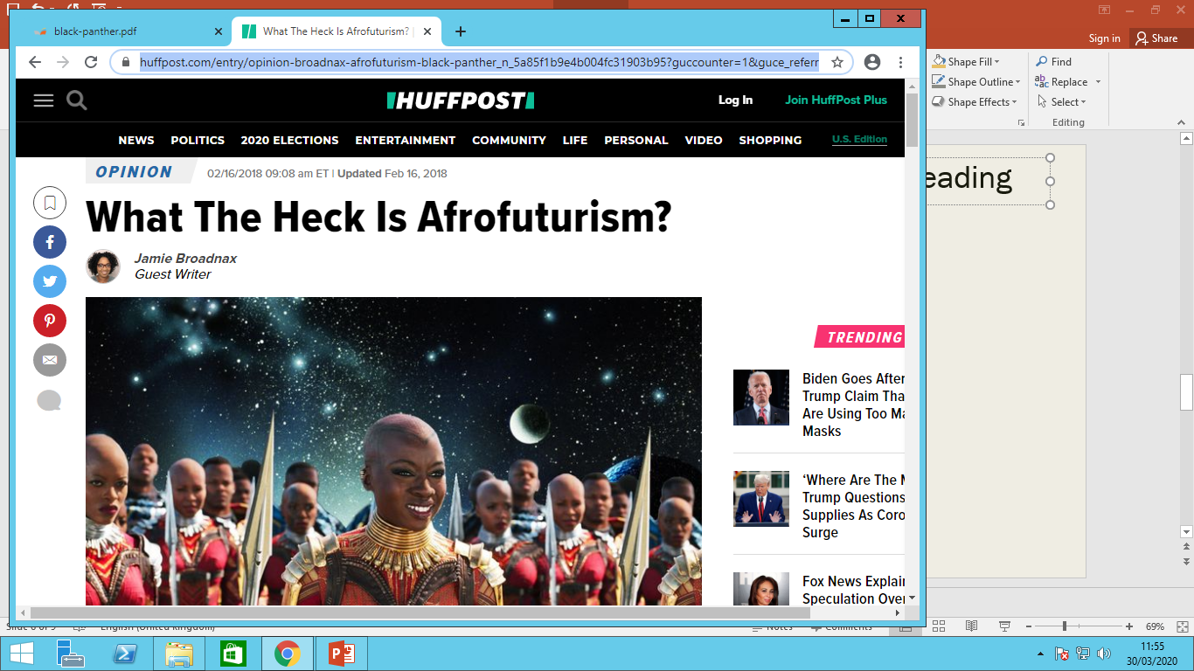

YouTube Viewing:

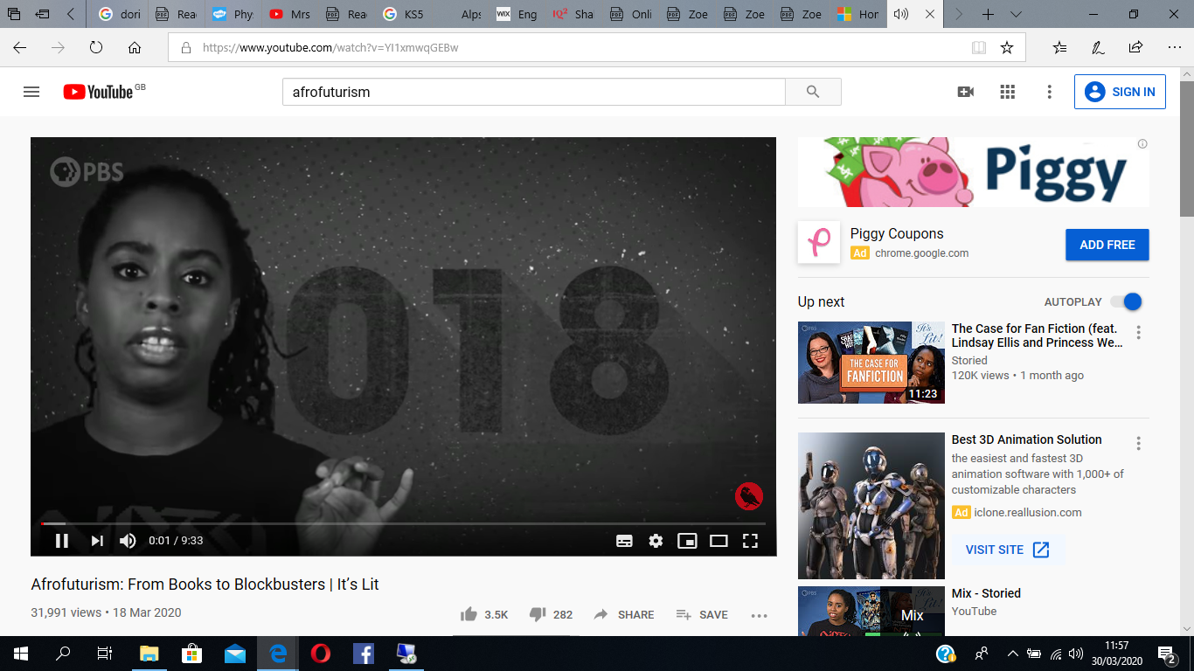

Cultural Context Overview

-

-

-

-

-

To what extent is Black Panther an Afrofuturist film?