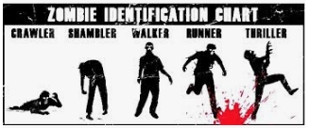

Additional reading Notes

Additional reading Notes

Genre and Narrative Notes

RESISTS Elements

R

E

S

I

S

T

S

Notes from Additional Viewing/Zombie conventions