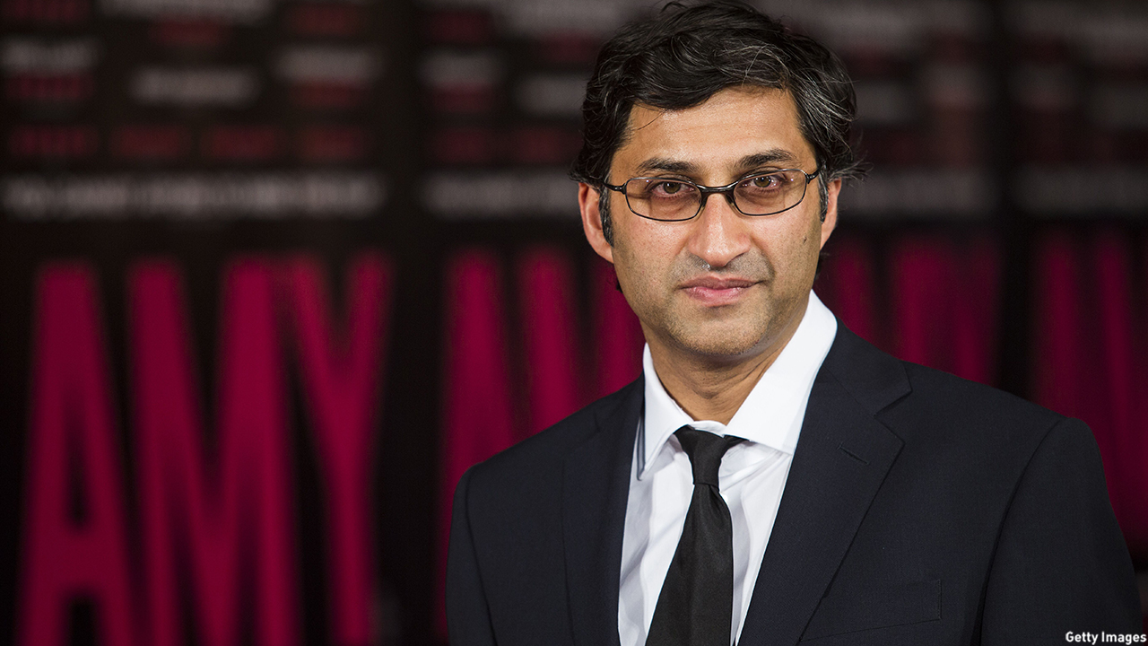

**Similarities in approaches:**

**Asif Kapadia’s style in Amy**

**Differences in approaches:**

**Michael Moore traits**

**Kim Longinotto Traits**

**Asif Kapadia**