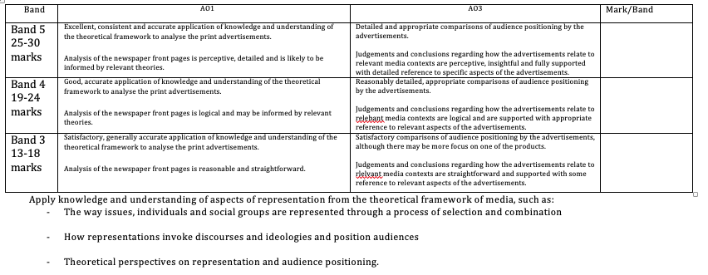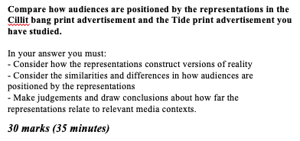





Introduction

Introduce source A (Genre/Purpose/Representation):

Introduce source B (Genre/Purpose/Representation):

Outline structure of response:

Conclusion

Summarise audience positioning of both sources.

Summarise Key similarities & differences

Paragraph 3 - Comparisons

Comparison 1 (similarity):

Comparison 2 (difference):

Comparison 3 (similarity or difference):

Paragraph 2 – Source B (CILIT BANG)

Audience Positioning:

Representations (which create audience position):

Evidence (Composition):

Explain:

Evidence (Image):

Explain:

Evidence (Typography):

Explain:

Evidence (Content/Language):

Explain:

Paragraph 1 – Source A (TIDE)

Audience Positioning:

Representations (which create audience position):

Evidence (Composition):

Explain:

Evidence (Image):

Explain:

Evidence (Typography):

Explain:

Evidence (Content/Language):

Explain: