The metrosexual is dead. Long live the 'spornosexual'
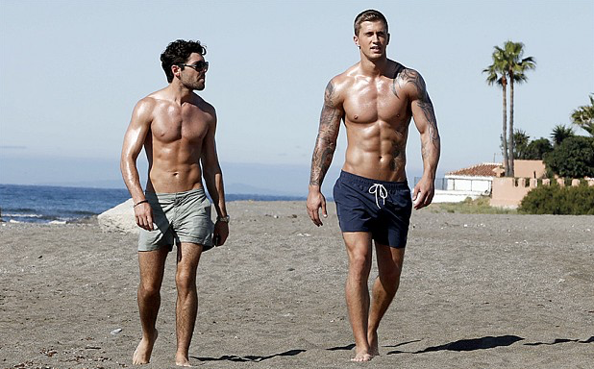

In a development which will probably have him running to the mirror yet again to search anxiously for lines, this year the metrosexual leaves his teens and turns 20.
How quickly your children grow up. Although it seems only yesterday, I first wrote about him in 1994 after attending an exhibition organised by GQ magazine called "It’s a Man’s World". I’d seen the future of masculinity and it was moisturised.
"Metrosexual man, the single young man with a high disposable income, living or working in the city (because that’s where all the best shops are) is perhaps the most promising consumer market of the decade," I predicted.

Two decades of increasingly out and proud – and highly lucrative – male vanity later, and the metrosexual remains the apple of consumerism’s rapacious eye. In a recent report, HSBC drooled all over his "Yummy"-ness, pointing out how mainstream metrosexuality has become.
This was of course old news to anyone with eyes to see the extremely image-conscious and product-consuming men around them – or in bed with them. Or the way that the glistening pecs and abs of men’s health and fitness magazines have been outselling the "lads' mags" for several years.
Or indeed anyone who saw the news last year that men in the UK now spend more on shoes than women.
From the perspective of today's fragranced, buffed, ripped, groomed, selfie-adoring world, it's hard to believe that the metrosexual had to struggle to be heard in the early 1990s. Most people were in "New-Lad" denial back then about what was happening to men and why they were taking so long in the bathroom.

Metrosexual 2.0: rugby player turned model Thom _{Evans (Photo: D Hedral)}

To illustrate this, I only have to say two words: David Beckham, the working-class England footballer who became more globally famous for his attention-seeking haircuts, unabashed prettiness and rampant desire to be desired than for his footballing skills. Once the sari-wearing midfielder was outed in 2002 (by me again, sorry) as the ultimate metrosexual, everyone suddenly "got it". All that Nineties denial turned into incessant Noughties chatter about metrosexuals and "male grooming". But still people failed to understand what was really going on with men.
In fact, the momentous nature of the masculine revolution that metrosexuality represents has been largely obscured by much of the superficial coverage it got. Metrosexuality is, in a paradox that Wilde would have relished, not skin deep. It’s not about facials and manbags, guyliner and flip flops. It’s not about men becoming "girly" or "gay". It’s about men becoming everything. To themselves. Just as women have been encouraged to do for some time.
This uptake by men of products, practises and pleasures previously ring-fenced for women and gay men is so normal now – even if we still need to be reassured with the word "man" or "guy" emblazoned on the packaging, like a phallic pacifier – that it’s taken for granted by young men today who really have become everything. So much so that it can be too much for the older generation of metrosexuals.

With their painstakingly pumped and chiselled bodies, muscle-enhancing tattoos, piercings, adorable beards and plunging necklines it’s eye-catchingly clear that second-generation metrosexuality is less about clothes than it was for the first.

Eagerly self-objectifying, second generation metrosexuality is totally tarty. Their own bodies (more than clobber and product) have become the ultimate accessories, fashioning them at the gym into a hot commodity – one that they share and compare in an online marketplace.

This new wave puts the "sexual" into metrosexuality. In fact, a new term is needed to describe them, these pumped-up offspring of those Ronaldo and Beckham lunch-box ads, where sport got into bed with porn while Mr Armani took pictures.
Let's call them "spornosexuals".

But unlike Beckham's metrosexual ads of old, in which his attributes were possibly artificially enhanced, today’s spornosexuals have photoshopped themselves in real life. Think Towie's Dan Osborne in a pair of glittery Speedos (and then have a lie down.)

Glossy magazines cultivated early metrosexuality. Celebrity culture then sent it into orbit. But for today’s generation, social media, selfies and porn are the major vectors of the male desire to be desired. They want to be wanted for their bodies, not their wardrobe. And certainly not their minds.
I suspect Wilde might have approved.

