The woman in seen smiling and in the middle of a workout.

There are women in the foreground and in the background of the advertisement that are wearing everyday clothing.

The costumes of the women are colourful and bright.

This Girl Can decided to use a non-celebrity woman as the main image.

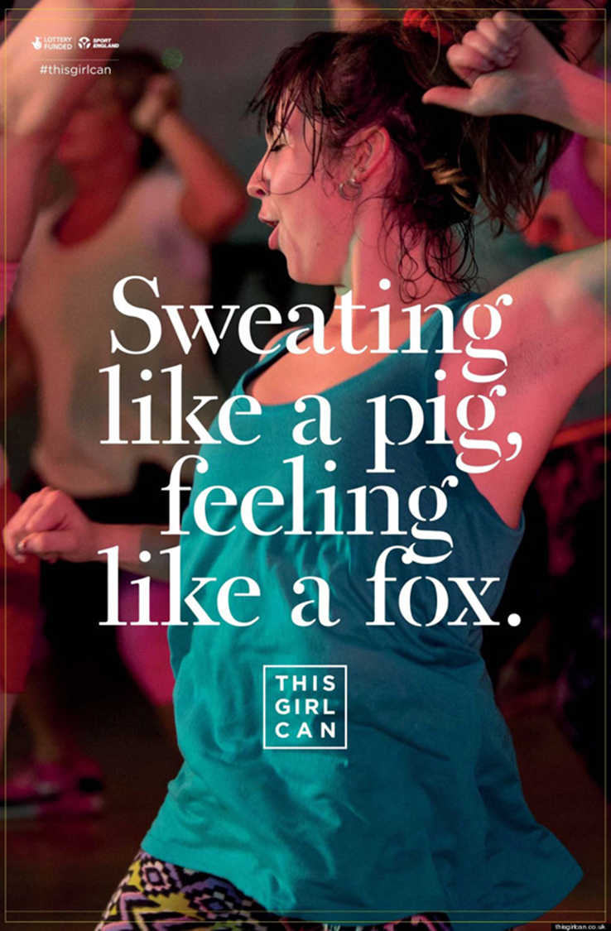

There is a reddish glow to the picture.

The woman is wearing baggy clothing, and is sweating a lot.

The mantra of the campaign is “sweating like a pig, feeling like a fox”.

At the top left hand corner there is the hashtag #thisgirlcan that connects readers to the campaign’s social media pages.

The mantra is written over the woman exercising.

The name of the campaign is “This Girl Can”.

**The font of the mantra is modern and white.**