Vladimir Propp was a folklorist researcher interested in the relationship between characters and narrative.
Propp argued that stories are character driven and that plots develop from the decisions and actions of characters and how they function in a story.

He claimed characters could be classified into certain roles that progress a story.

Type of character | Example of character in Luther  (conformed/subverted?) | How the character was used to drive the narrative
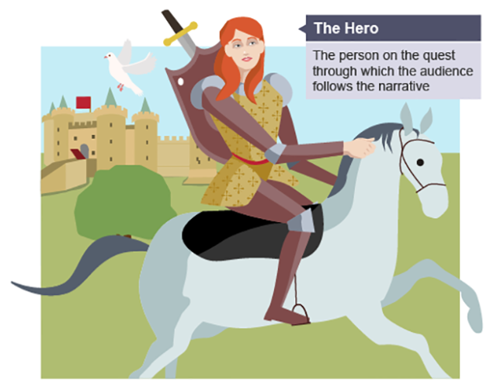
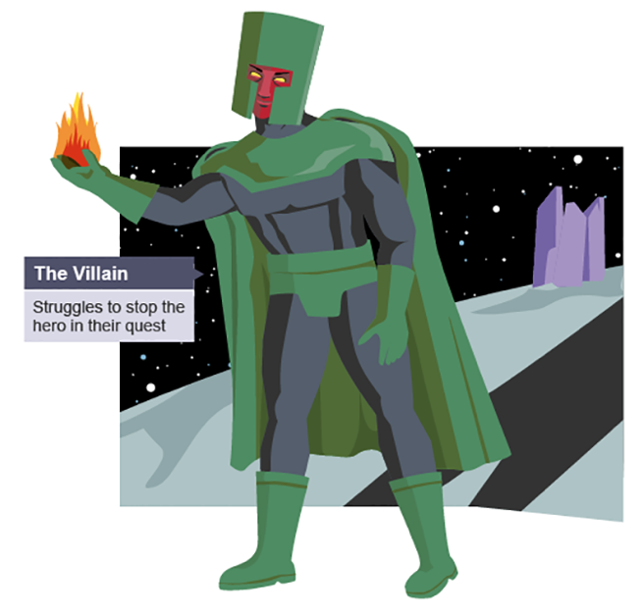
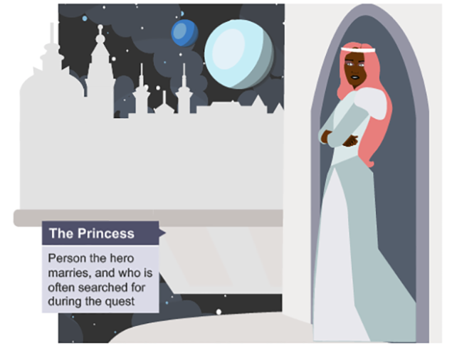
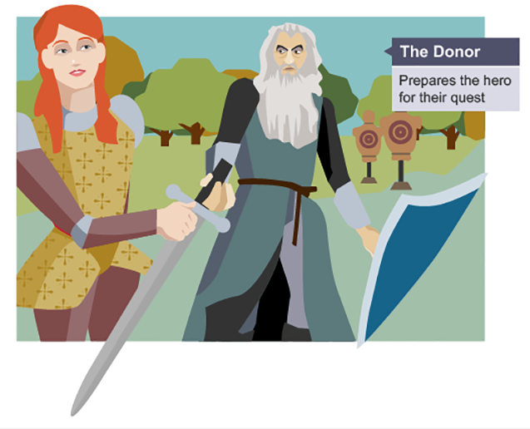
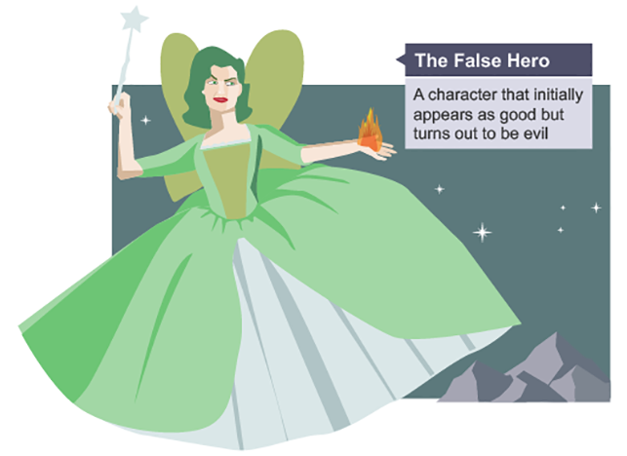
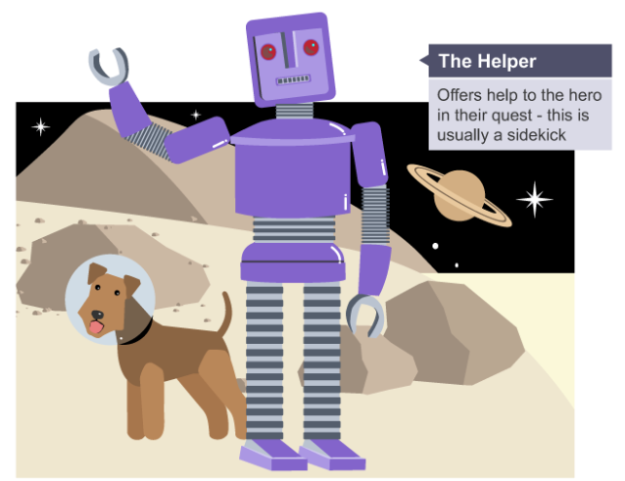
Overall did the characters within Luther conform to Propp’s theory or not?

Why do you think that this is?

