Ethnicity
Representations of ethnicity (black people) traditionally in the Media tend to highlight the following:
- Aggression
- Weakness
- Strength of body
- Dangerous
- Crime
- Overly sexualised
At the start of the 20th century, many films depicted black characters that supported the dominant stereotype of the time: incompetent, hypersexualised and/or criminals.

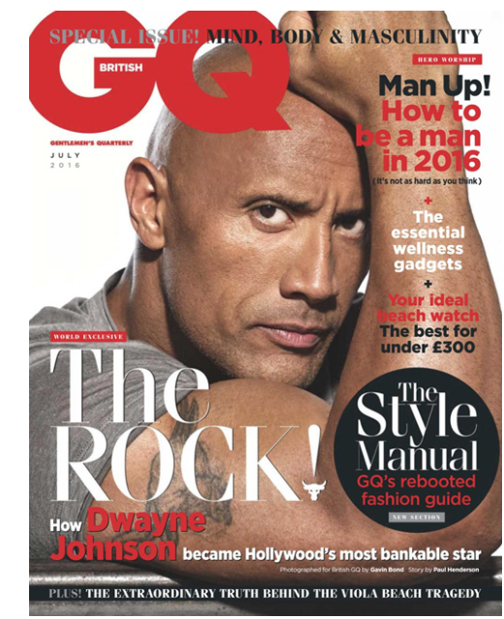
Identify the stereotypical/non-stereotypical representations within the magazine:
Decide whether the representation of black men reinforces or challenges the dominant ideologies. Explain.

Identify what the representation is - make a list of adjectives that describe how black men are represented.

