**Characters in SOTD**

**Shaun** - Simon Pegg **Ed-** Nick Frost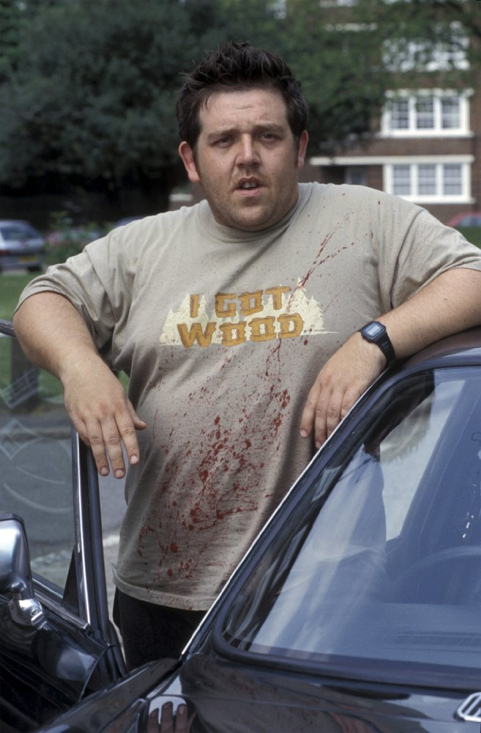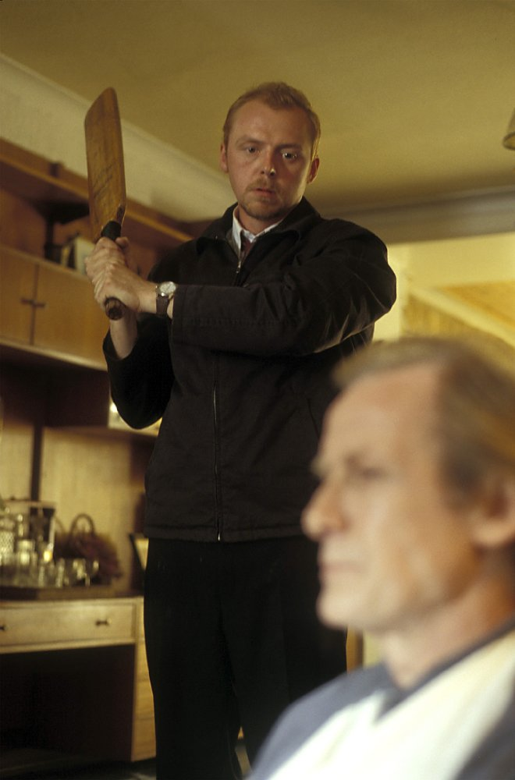

**Liz-** Kate Ashfield **Diane-** Lucy Davis

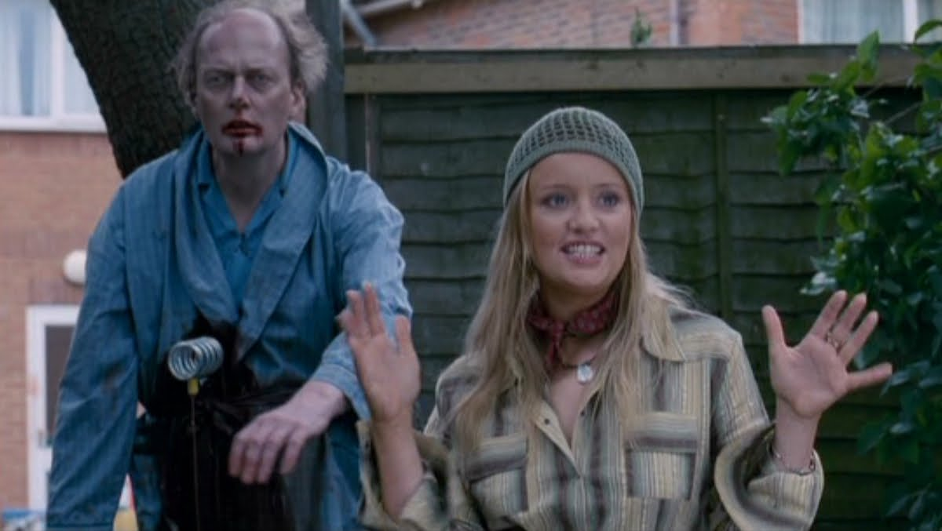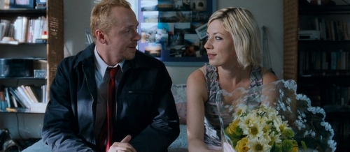

**David-** Dylan Moran **Pete-** Peter Serafinowicz

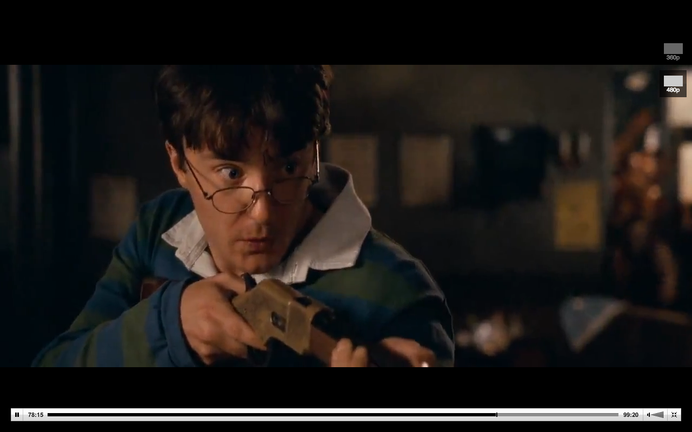

# **Philip-** Bill Nighy **Barbara-** Penelope Wilton

# 

# 

# **Yvonne-** Jessica Hynes

# 

# 

# 