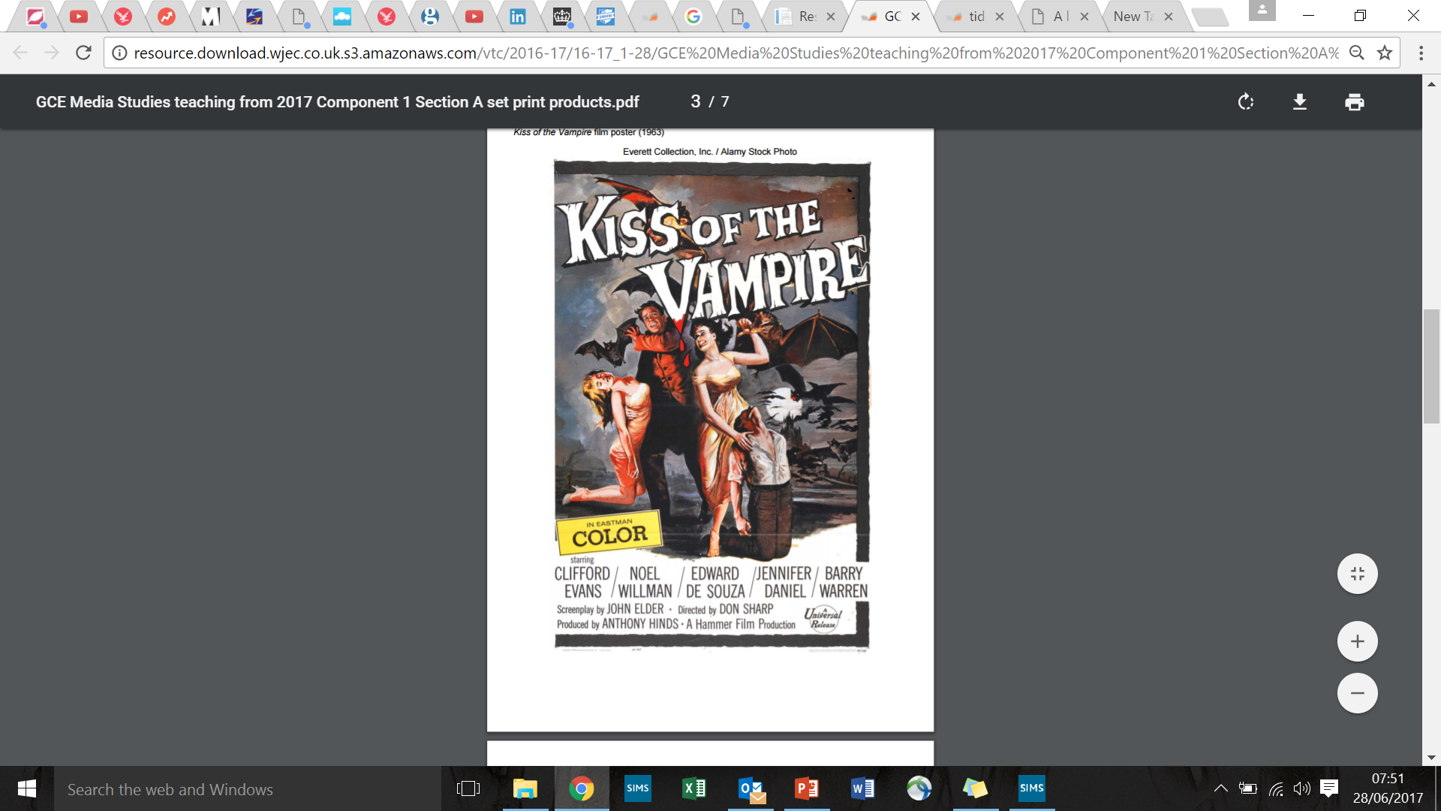

*THE HAY’S CODE (1930-1968):*

* *No picture shall be produced that will lower the moral standards of those who see it.*
* *Correct standards of life shall be presented.*
* *Law, natural or human, shall not be ridiculed, nor shall sympathy be created for its violation.*

*From a social/cultural/historical perspective, why do you think 1960s Horror films were not as graphic as films are today?*

*Vampire Movies (1980s-onwards):*

*Whilst Hammer movies of the 1960s and 1970s embraced sex and the promiscuous society, the 1980s saw a huge shift in peoples notions around sex.*

*The Aid’s epidemic devastated countless lives around the world. the idea of a disease being passed on via blood or sexual contact became a symbolic allegory (a story with a deeper meaning) to many. Old, dusty vampires were traded in for teenagers in films such as ‘The Lost Boys’ (1987) and ‘Buffy the Vampire Slayer’ (1992).*

*From a social/cultural/historical perspective, why has content (narrative, themes, ‘fears’) within Horror films changed since 1963?*

Media Contexts