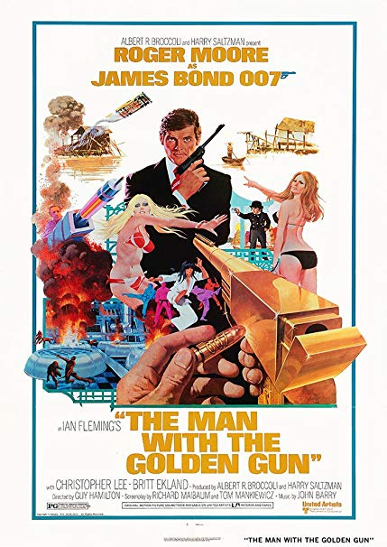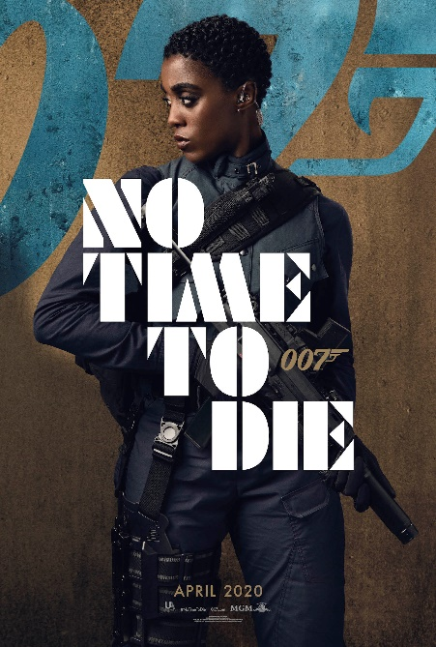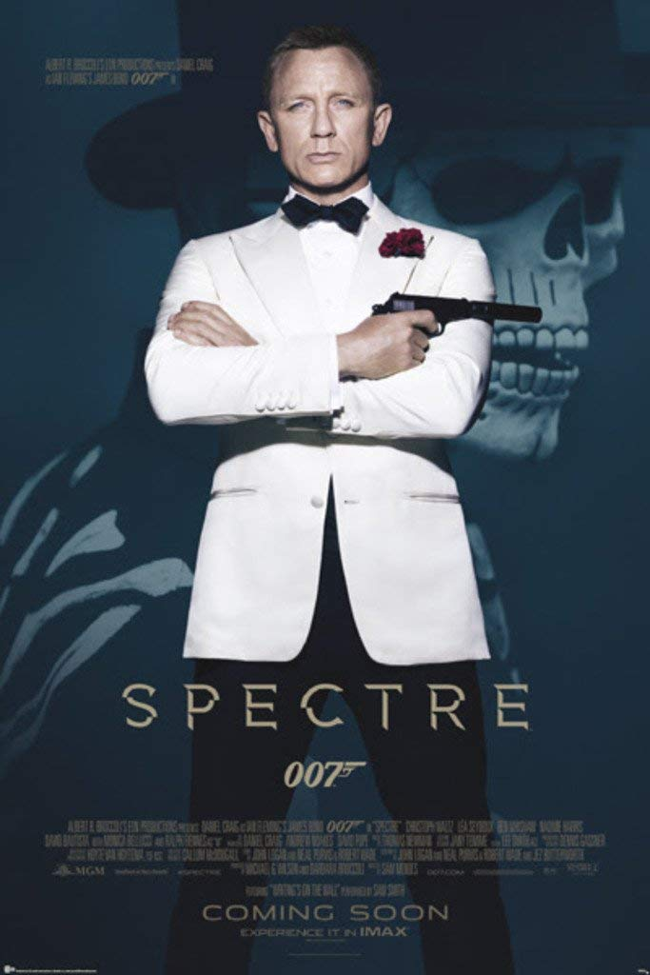**How has the representation of gender (men and women) within Bond film posters progressed through time?**

Things to consider: How are men being represented? How are women being represented? Are there any stereotypical/non-stereotypical representations? Is there any misrepresentation or under-representation? What viewpoints are constructed because of the representations?

Things to consider: How are men being represented? How are women being represented? Are there any stereotypical/non-stereotypical representations? Is there any misrepresentation or under-representation? What viewpoints are constructed because of the representations?

Things to consider: How are men being represented? How are women being represented? Are there any stereotypical/non-stereotypical representations? Is there any misrepresentation or under-representation? What viewpoints are constructed because of the representations?