

The font of the poster is written in gold and is very stylish. The typography of the title itself seems to be made up of various parts coming together like a puzzle.

Daniel Craig’s credited name is written in small font which is unconventional of film posters trying to create a buzz through the use of star appeal.

Extension Task: Try to identify all of the “Bond” iconic conventions within the poster.

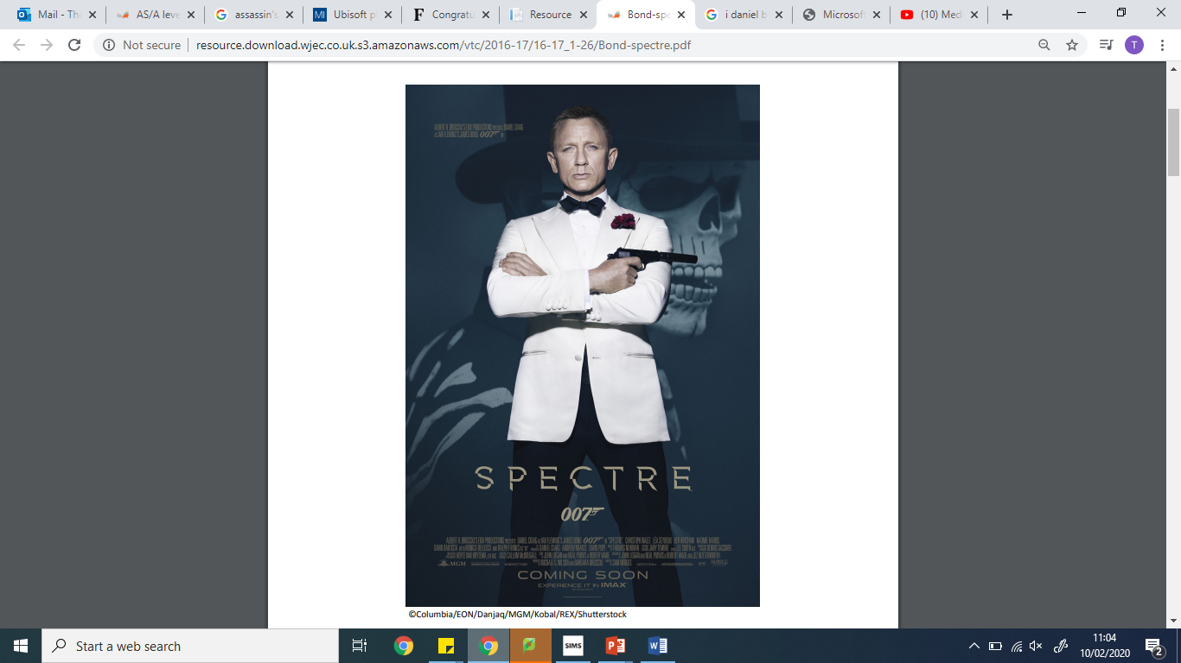

James Bond is lit up with the use of high-key lighting, whereas the rest of the poster is dark and ominous.

James Bond’s facial expression is calm and collected but serious in it’s tone.

The skeleton in the background is wearing a top hat. How would these relate to the day of the dead festival?

The 007 logo features twice on the poster. The logo’s 7 is designed to look like a gun.

James Bond is wearing a black tuxedo with a red rose on the left side of his chest.

James Bond is stood in the forefront with a skeleton looming in the background looking over his shoulder.

James Bond is holding a black silenced pistol with his finger on the trigger.

The title says “Spectre” which means ghost/spirit.

There is text that explains that the film will be distributed to IMAX “Experience in IMAX”. IMAX is a world-renowned cinema experience as the screens are some of the largest in the world.