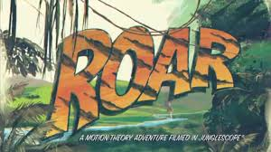

**Genre**

Katy Perry – Roar is a hybrid of the performance and narrative genres. List some examples of the genre’s conventions being conformed to specifically from the video itself.

* Performance -
* Performance -
* Performance -
* Narrative -
* Narrative -

**Media Language & Representation Analysis**

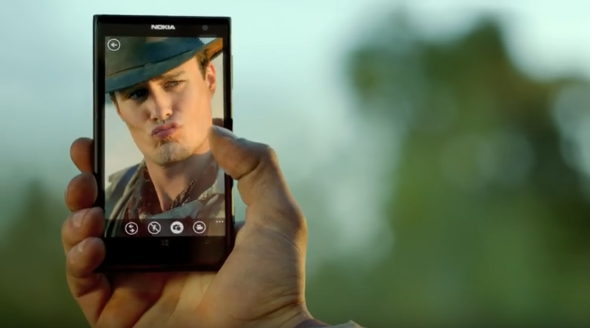

*Point of view shot of a man wearing a cowboy hat (similar to that worn by Indiana Jones) who is taking a selfie of himself whilst pouting. The background/setting depicts a green jungle.*

*What are the connotations of the denotative comments above?*

*How has gender been represented in this shot?*

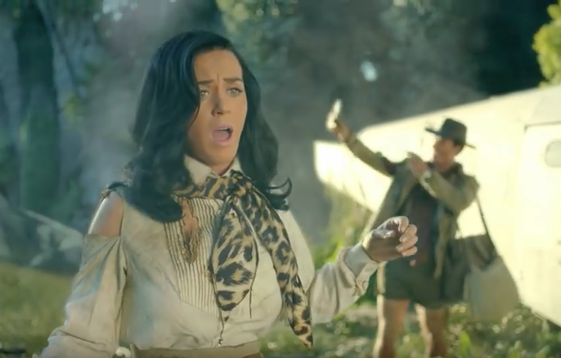

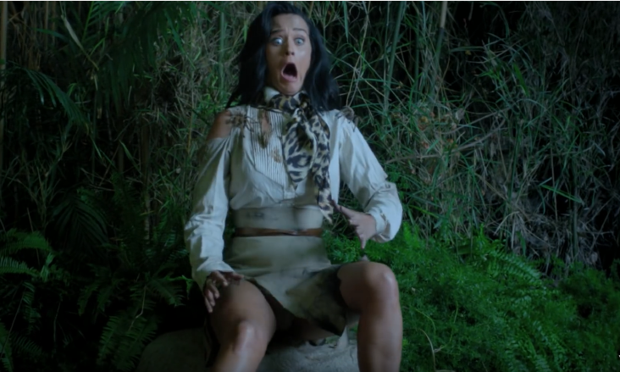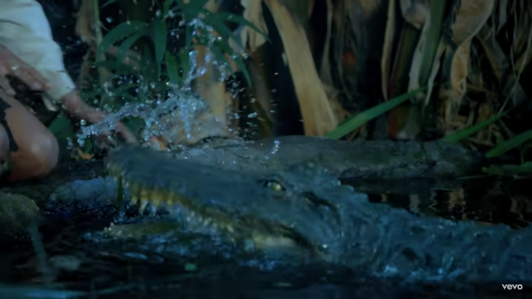

*Quick shots at night depict Katy Perry interacting with her new environment. She crouches down to drink water and is attacked by a crocodile and is covered in big spiders when she sits down. In all shots her mouth is wide open and she has wide eyes.*

*What are the connotations of the denotative comments above?*

*How has gender been represented in this shot?*

*Mid-shot of Katy Perry looking frazzled with torn clothes similar to what a cabin crew worker would use. Her mouth is wide open and she looks as if she is about to cry. In the background the audience can see the Indiana Jones lookalike still taking selfies and wearing clothing suitable to the environment.*

*What are the connotations of the denotative comments above?*

*How has gender been represented in this shot?*

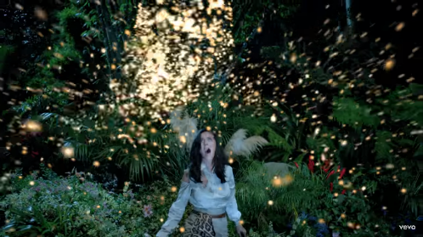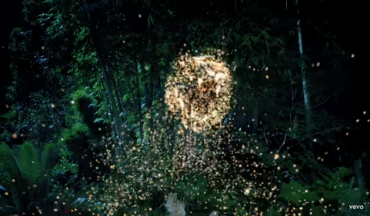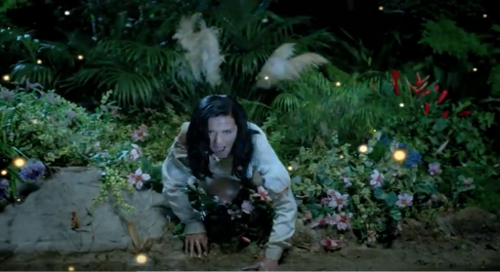

*High angle shot of Katy Perry crouching by some water on all fours. As she sings “eye of the tiger…and you’re gonna hear me roar” golden fireflies form the shape of a tiger head which is roaring along with her. Throughout this shot Katy is surrounded by jungle, grass, and colourful flowers.*

*What are the connotations of the denotative comments above?*

*How has gender been represented in this shot?*

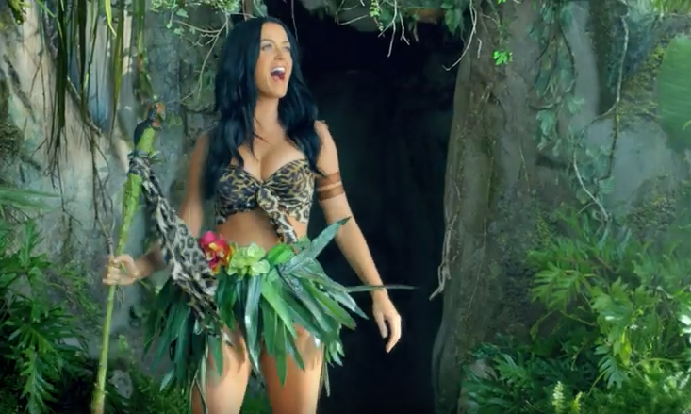

*A long shot of Katy Perry is seen with a stick fashioned into a hunting spear. She has adapted her scarf into a top which covers only her breasts and leaves into a short skirt. She is showing a lot of flesh and her muscular body. She seems to be living in a dark cave.*

*What are the connotations of the denotative comments above?*

*How has gender been represented in this shot?*

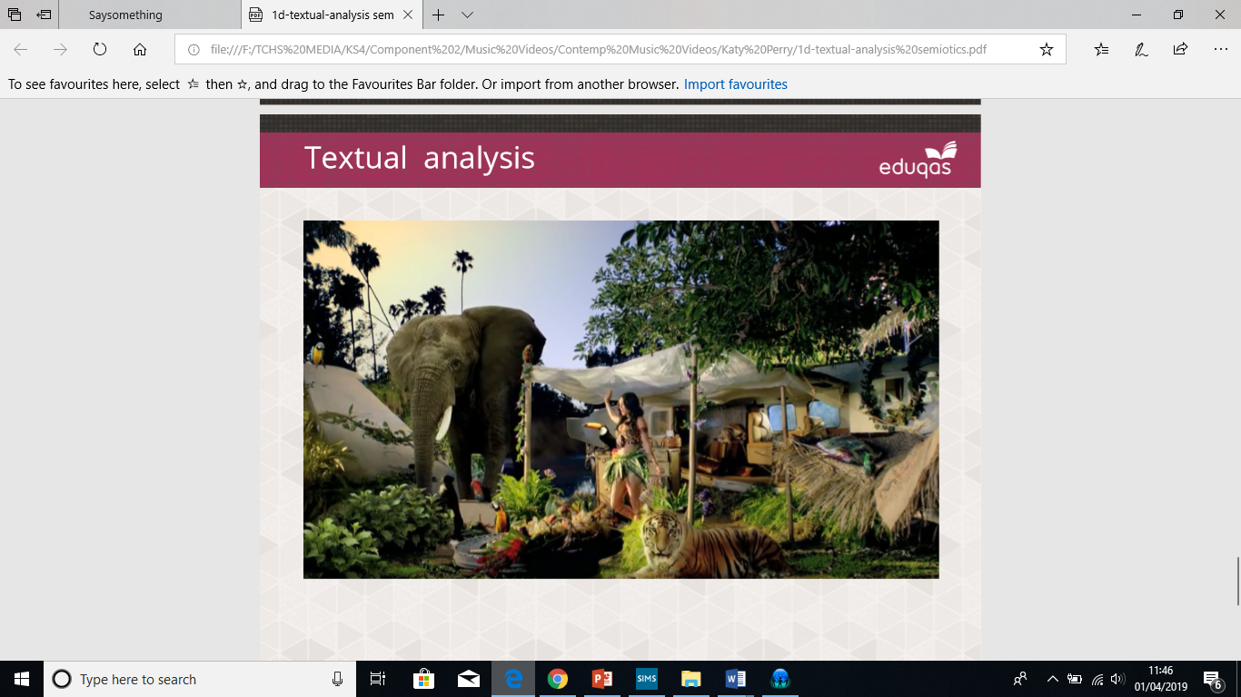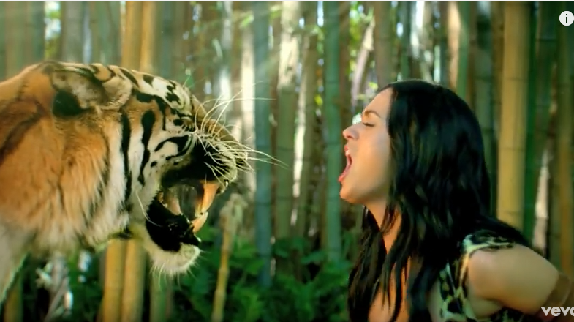

*A wide shot is seen of Katy Perry face to face with a tiger. Both characters seem to be roaring – which allows the audience to see the tiger’s large canine teeth.*

*What are the connotations of the denotative comments above?*

*How has gender been represented in this shot?*

*An establishing shot presents the audience with a view of the home that Katy has made out of the plane wreckage. The home is surrounded by colourful wild animals, including an elephant and a tiger.*

*What are the connotations of the denotative comments above?*

*How has gender been represented in this shot?*

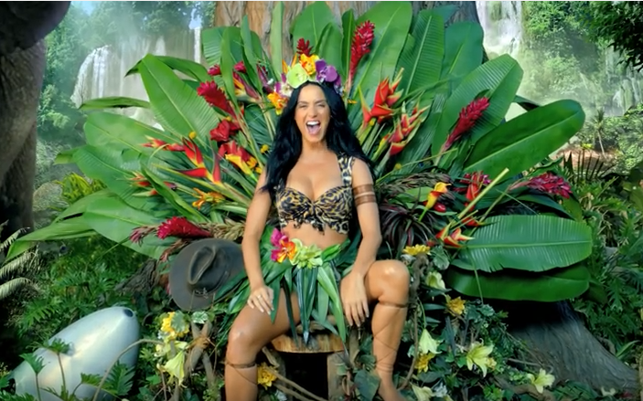

*A long shot is seen of Katy Perry sitting on a throne made of leaves. She has a wide smile and is wearing her make-shift costume. Next to her is the hat worn by the man seen in the earlier part of the video.*

*What are the connotations of the denotative comments above?*

*How has gender been represented in this shot?*