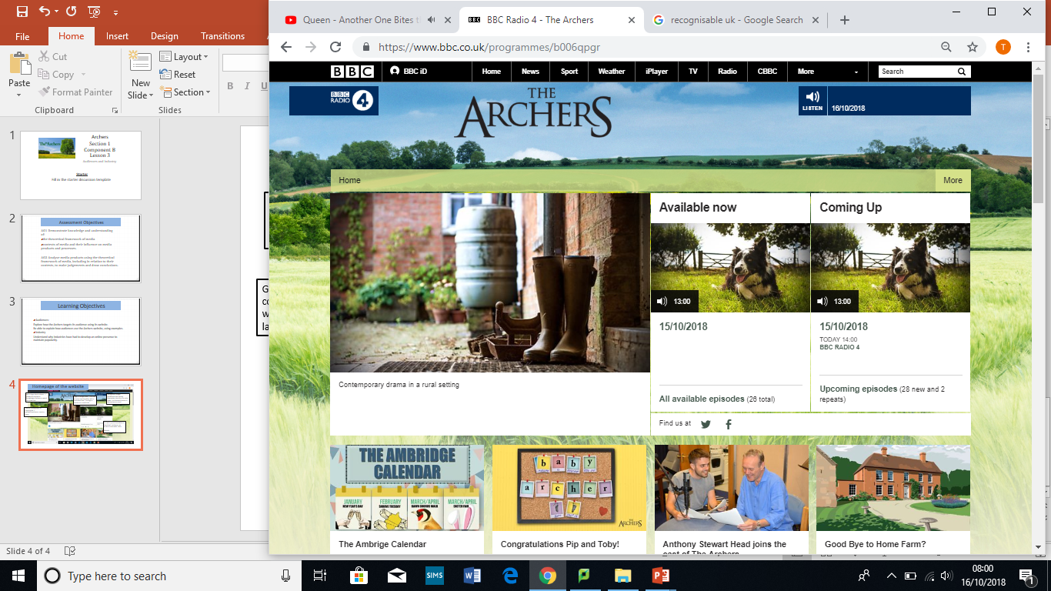

Which contemporary and relevant sub-pages can you find?

How do the images, photographs, names of articles and logo meet the expectations of the audience? How is brand identity maintained?

Why would the Archers audience demand a website?

What are the benefits?

The website brings the characters to life. Why is this important when attracting and maintaining audiences?