Ofelia  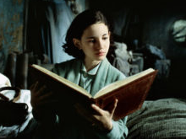  Representation:  Characteristics:  Contexts:  Key scenes: | Captain Vidal  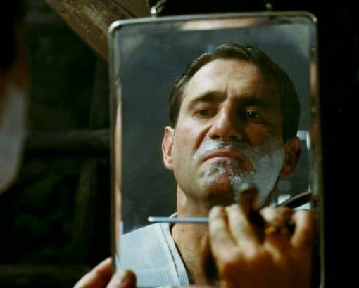  Representation:  Characteristics:  Contexts:  Key scenes:
Mercedes  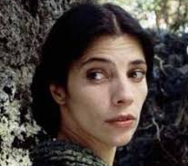  Representation:  Characteristics:  Contexts:  Key scenes: | The Faun  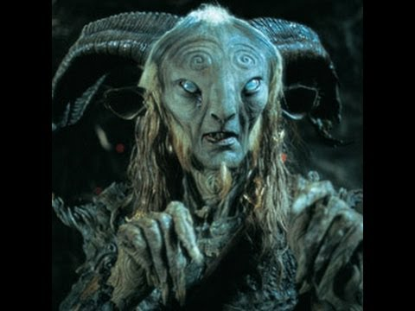  Representation:  Characteristics:  Contexts:  Key scenes:
The Pale Man  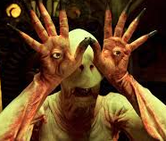  Representation:  Characteristics:  Contexts:  Key scenes: | Carmen  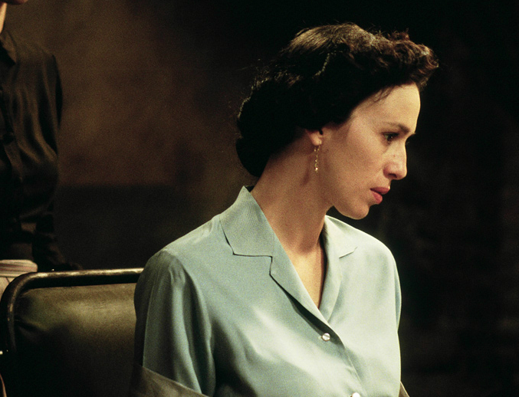  Representation:  Characteristics:  Contexts:  Key scenes:
Dr Ferreiro  Representation:  Characteristics:  Contexts:  Key scenes: | Representation:  Characteristics:  Contexts:  Key scenes:

