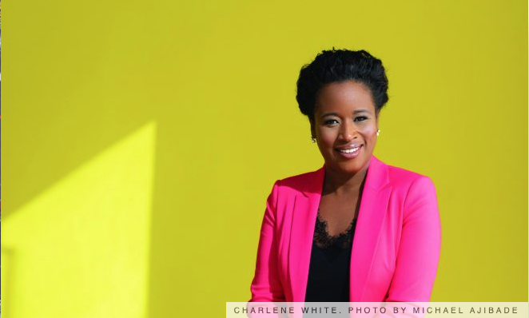

CAREERS

Careers: A Spotlight on Charlene White
ITV News anchor Charlene White tells us about her career, rising above harsh comments and her passion for bringing in the next generation of broadcast journalists
She became the first black woman to host News At Ten in 2014, and was one of their youngest-ever presenters at the time she joined the news station in 2008.
However, Charlene White is not satisfied with having broken new ground through her own achievements; she pays it forward. The south London-born broadcaster has been instrumental in establishing the scheme ‘Breaking Into News’, a competition now in its eighth year that welcomes winning applicants into ITV newsrooms nationwide – regardless of age, financial status, level of education or cultural background. The product of Media Trust and ITV, Breaking Into News has been part of White’s professional life since its very first year, and she and ITV London’s Ria Chatterjee have been working hard to ensure that 2019 has a large, varied pool of candidates.
We caught up with Charlene White at the ITN Building in London, where she told us about acknowledging the impact of her being a national broadcaster, the process of changing hairstyles and why newsrooms need to widen their hiring pool.
I first realised that I was doing something significant about a year before starting at ITV, while working for the BBC Look East, in Norwich.
After my first presenting shift on the afternoon news, a woman rang up to complain about me being on the TV. Her words were: ‘Has the BBC run out of white presenters? Why is this woman on my TV?’ She said she thought it was ‘disgusting’ that the BBC were employing ‘presenters where English wasn’t their first language’ – and no-one on my team wanted to tell me. When I heard, I found it absolutely hilarious! I said it was shocking that no-one thought that was going to happen – I expected it, because it was an unusual thing for viewers in that part of the UK to see me doing the news at that point. I think that that’s when I realised I’m having an impact, and a good impact, because I don’t care if someone is uncomfortable with seeing me on the TV. In my head, this is the new world order – no-one’s going to stop me from doing my job because they don’t particularly like the colour of my skin. It’s always good to ruffle a few feathers.

‘NO-ONE’S GOING TO STOP ME FROM DOING MY JOB BECAUSE THEY DON’T PARTICULARLY LIKE THE COLOUR OF MY SKIN.’

