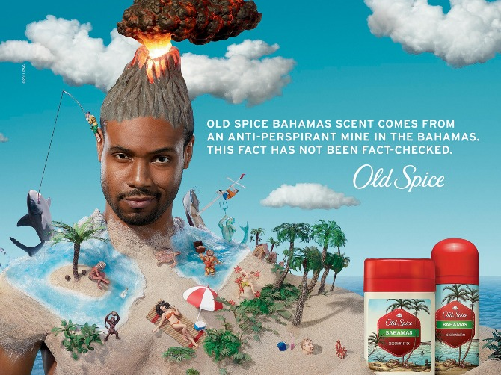

This text needs to be revised in regards to:
- Media Language (semiotic analysis & genre)
- Representation (how males and race are represented)
- Social and Cultural Context (how the outside world influences the creation of the product, and vice versa).
Practice Questions
- Explain the significance of intertextuality in advertising. Refer to the Old Spice advertising campaign in your answer. [10]

- Explain how the media language in advertising incorporates the brand image the advertisers wish to convey. Refer to the advertisements for Old Spice and Lucozade you have studied to support your answer.

- Analyse why postmodern techniques are used in the Old Spice advert you have studied

- Analyse how the advertisements in (Fig 1 and Fig 2) use media language to appeal to the audience.
In your answer you must:
• analyse the use of media language in appealing to a target audience
• make judgements and reach a conclusion about why these companies advertise in this way. [15]

Media Language Revision Questions
- Analyse how a combination of elements (layout/language/image/content) have created meaning using semiotics.

- What are the generic conventions of the media form (advertising) and how have they changed over the years?

- How does the media language incorporate viewpoints and ideologies?

- What are the intertextual examples related to the set advertisement (Old Spice)?

Representation Revision Questions
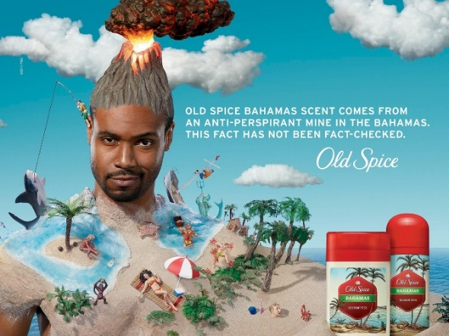

- How does selection and combination create representations of race and gender in the set text?

- How does the set text seemingly create a sense of realism and construct a version of reality?

- Analyse and explain the impact of social and cultural contexts on how producers choose to represent groups of people and places in the set text.

- Analyse and explain positive and negative uses of stereotyping.

- Analyse and explain how representations may invoke discourses and ideologies and position audiences to act/think in a certain way.

Fig 2

