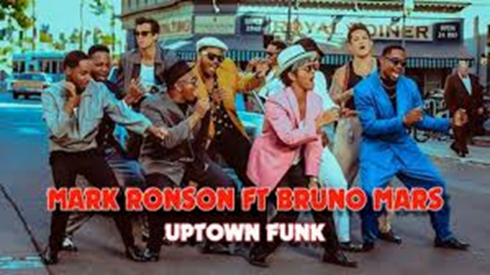

Industry
The song Uptown Funk was produced by RCA Records – which is a subsidiary company owned by SONY Music. What is the advantages of working for a conglomerate company?

One of the directors for the song Uptown Funk was Mark Ronson. Ronson has directed, produced and at times starred in lots of collaborations with stars such as Lily Allen, Adele, Lady GaGa and Amy Whinehouse. Why would Bruno Mars have accepted to work with Ronson?
Industry Research
- Uptown Funk was the fifth music video to achieve what?

- How many UK Number One hit singles has Bruno Mars had in total – and what number was Uptown Funk?

- How many songwriters have now been credited for Uptown Funk?
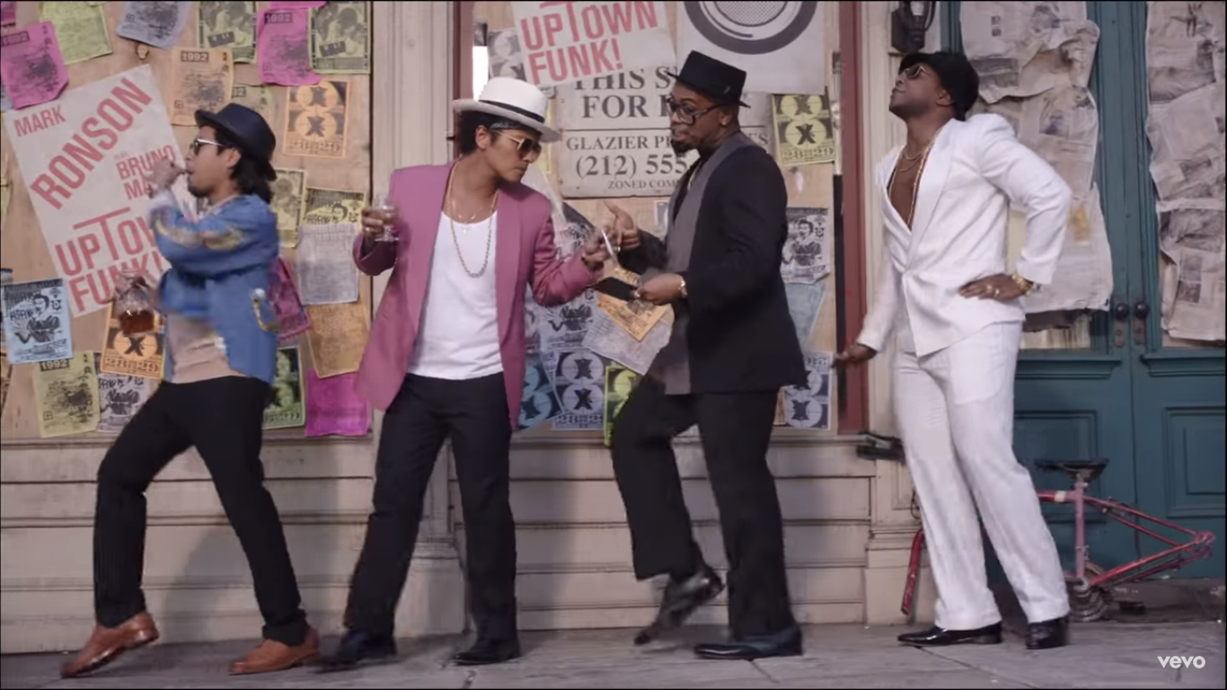
- What was the scandal surrounding songwriters?
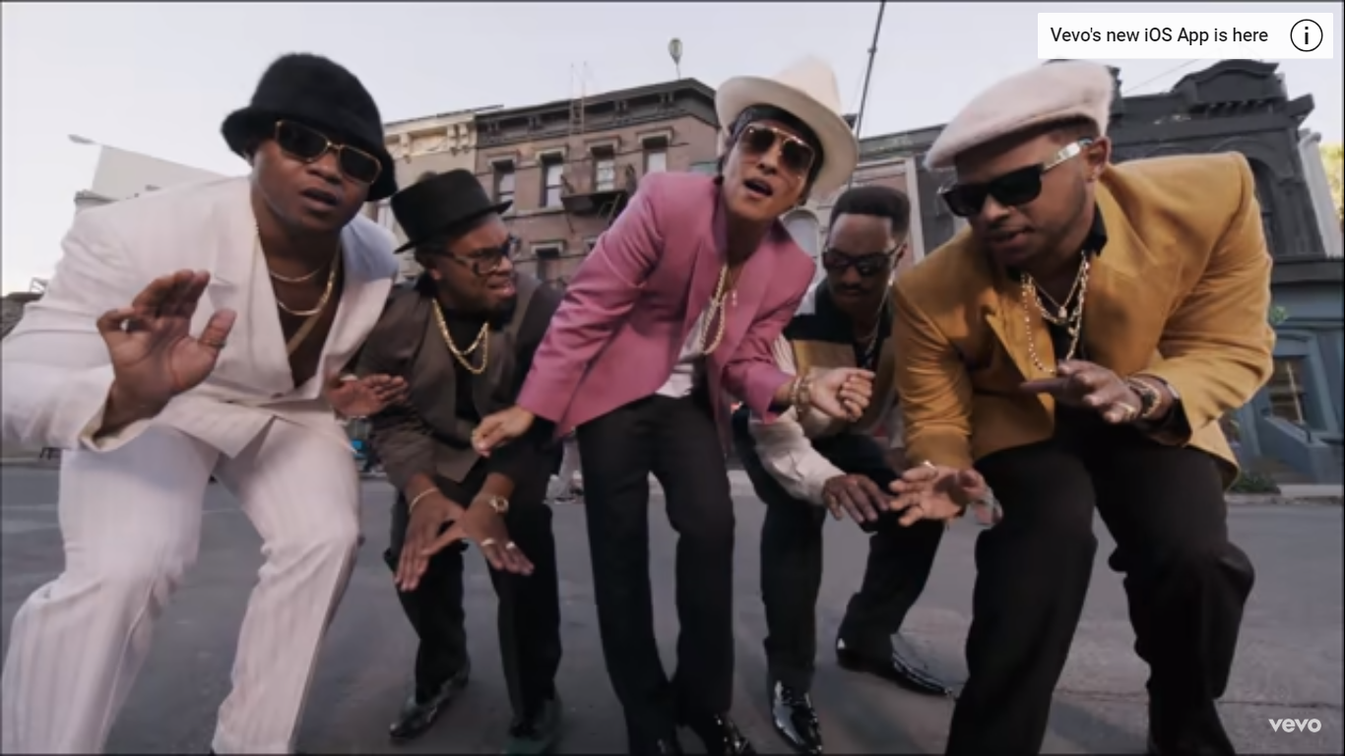
Audience
Looking at the screenshots to the right, identify 3 potential audiences of Bruno Mars Uptown Funk and explain why that audience would be appealed to the music video.
Audience 1

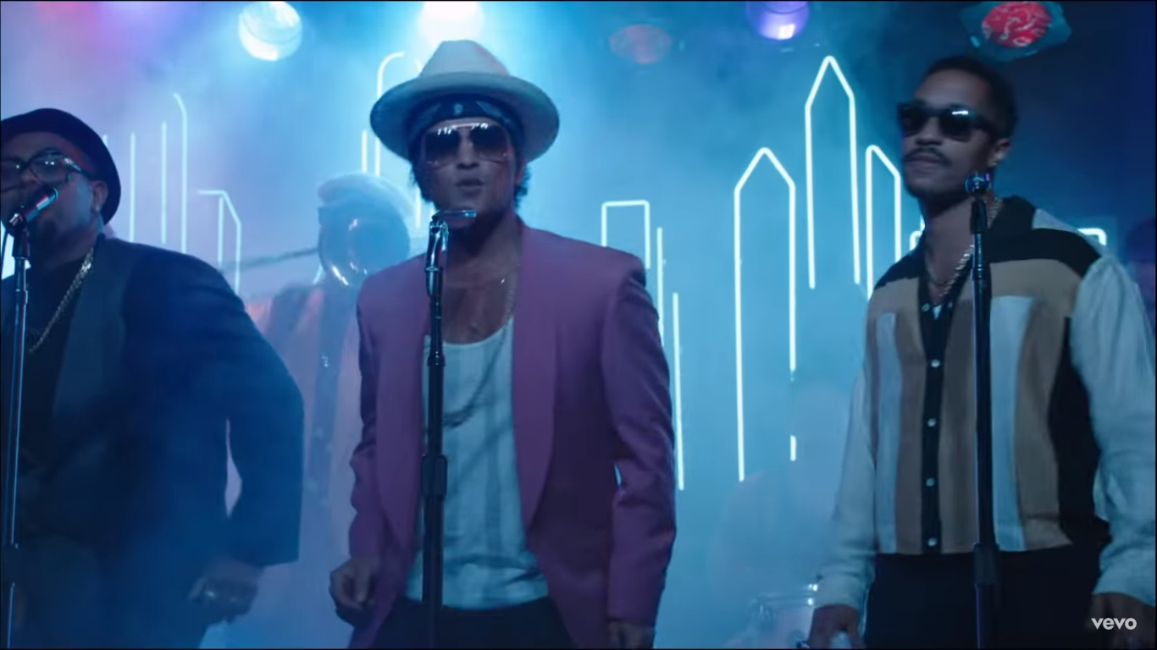

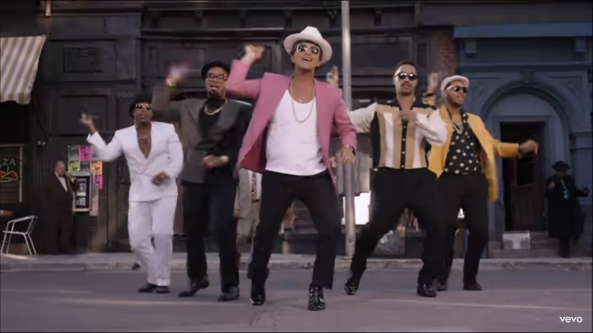
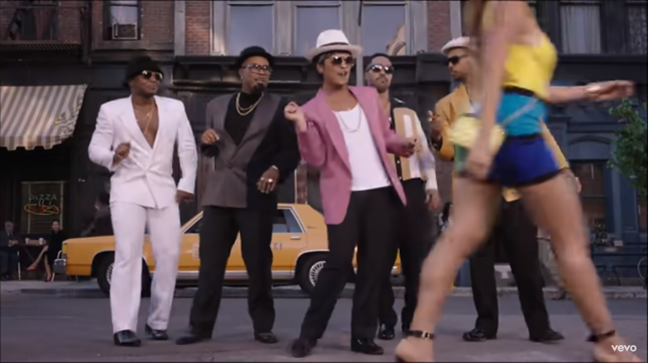
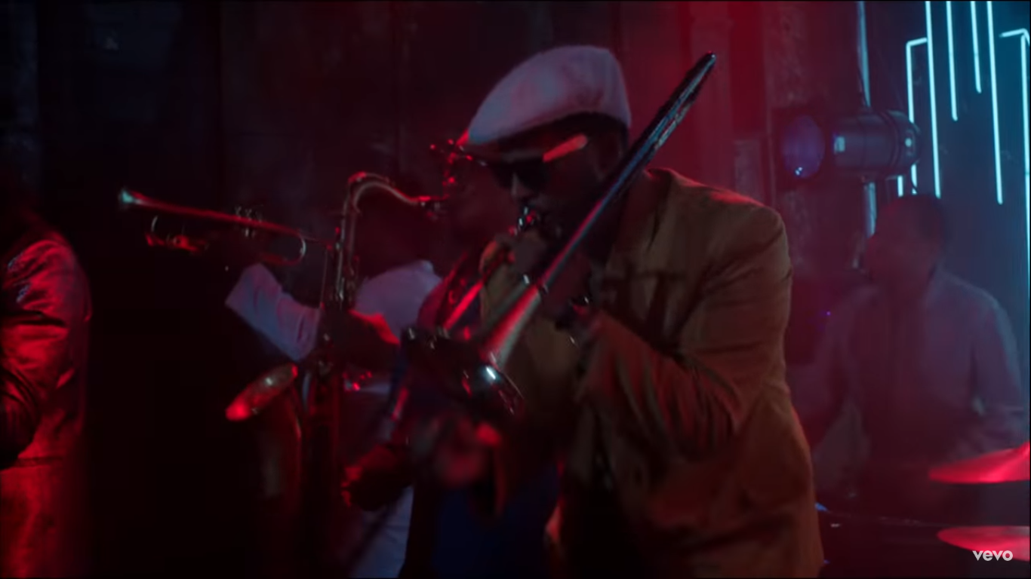
Looking at the screenshots to the right, identify 3 potential audiences of Bruno Mars Uptown Funk and explain why that audience would be appealed to the music video.
Audience 2

Audience 3

Apply the uses and gratifications theory to the music video of Uptown Funk
D
I
V
E
R
S
I
O
N
I
D
E
N
T
I
T
Y
S
U
R
V
E
I
L
E
N
C
E
R
E
L
A
T
I
O
N
S
H
I
P
S

