Vogue's "Diverse" Cover Slammed for Not Being Diverse Enough
"The public to Vogue: 'We need diversity!!'
Vogue: *Gets Kendall and Gigi again.*"

Vogue made waves yesterday, when it released its March 2017 "Modern American Woman" issue featuring seven models — Liu Wen, Ashley Graham, Kendall Jenner, Gigi Hadid, Imaan Hammam, Adwoa Aboah, and Vittoria Ceretti — from different ethnic backgrounds. It also put Ashley, a size-16 model, front and center. While the cover garnered praise for its inclusivity, it faced backlash on social media for not being more inclusive.
According to commenters, one "plus-size" model doesn't make up for the fact that the rest of the women on the cover are around six feet tall and very slim, and that none of the models featured were "darker than a paper bag."
Additionally, commenters took issue with how Ashley was posed for the cover shot. They pointed out that her arm was the only one resting on a thigh, which arguably covers up her torso. Eagle-eyed Twitter users also thought there was something fishy about the placement of Gigi Hadid's arm and hand — a Photoshop tactic they claimed was meant to cover up Ashley's stomach.
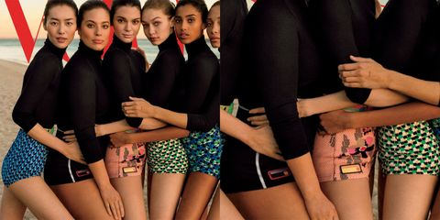
Ashley defended Vogue and her pose in the comments on her Instagram post of the cover. "I chose to pose like that,” she wrote. “No one told me to do anything." She also shared two more photos from the inside story, and expressed her gratitude to the publication, saying, "Dream. Come. True!" and "THANK YOU @voguemagazine for having me on your cover!!"

