Paper 1 Question 4 will always ask you questions regarding audiences and why they use certain set texts.
- The Sun Website
- Pokemon Go!
- The Archers
What the question will look like

Audiences
4. (a) Which game developer created Pokemon Go!?
4. (b) Identify one audience for Pokemon Go!
4. (c) Explain two ways in which The Archers is aimed at the audience you have identified.
4. (d) Explain why audiences play Pokemon Go!. Refer to the Uses and Gratifications theory in your response.

Guidance
4a – You need to be specific with who creates the product in question. E.G. For The Archers, the following responses are not valid – radio 4, BBC, BBC 4.
4b – Just say one audience that could use the product. No need to elaborate or give reasons why.
4c – Make sure that the reasons for using the text in question relates specifically to the audience you identified in question 4b!
4d – You must give new reasons for using the text. Make sure that you provide either specific evidence or specific facts regarding the text. You must also relate the evidence/facts to the uses and gratifications theory.

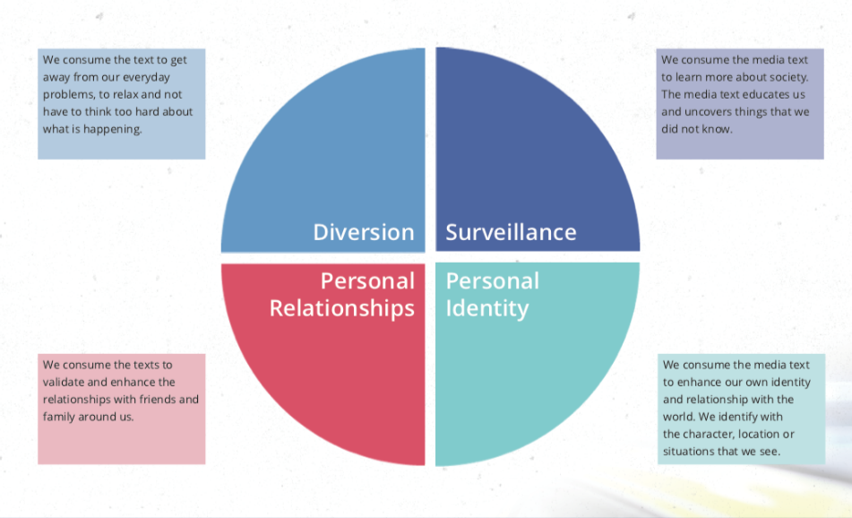
The Uses and Gratifications Theory

