BBFC Initial Viewing Report
Columbia submitted Spectre to the BBFC in August 2015, for advice on whether it was likely to meet the BBFC Guidelines criteria for 12A. At this stage the film had no title sequence, end credits were missing and some special effects work was unfinished, but the Senior Compliance Officers(then Senior Examiners) who viewed it noted it was 'largely complete'.  The BBFC advised that a 15 rating seemed the most probable outcome, citing strong bloody detail during a scene of eye-gouging and further bloody detail in the aftermath of the suicide of a terminally ill man.  Spectre also features a scene of torture in which Bond is strapped to a chair while a villain pierces his head with a micro-drill. | Were your predictions on what the film featured correct? How?  What age 15 criteria did the film feature? Refer to the age rating illustrations from earlier.  Extension: What could EON change with those scenes to make them appropriate for 12 years and above?

Age 12 Criteria Age 15 Criteria
Dangerous behaviour  No promotion of potentially dangerous behaviour which children are likely to copy. No glamorisation of realistic or easily accessible weapons such as knives. No endorsement of anti-social behaviour. | Dangerous behaviour  Dangerous behaviour (for example, suicide, self-harming and asphyxiation) should not dwell on detail which could be copied. Whether the depiction of easily accessible weapons is acceptable will depend on factors such as realism, context and setting.
Language  There may be moderate bad language. Strong language may be permitted, depending on the manner in which it is used, who is using the language, its frequency within the work as a whole and any special contextual justification. | Language  There may be strong language. Very strong language may be permitted, depending on the manner in which it is used, who is using the language, its frequency within the work as a whole and any special contextual justification.
Threat and horror  There may be moderate physical and psychological threat and horror sequences. Although some scenes may be disturbing, the overall tone should not be. Horror sequences should not be frequent or sustained. | Threat and horror  There may be strong threat and horror. A sustained focus on sadistic threat is unlikely to be acceptable.
Violence  There may be moderate violence but it should not dwell on detail. There should be no emphasis on injuries or blood, but occasional gory moments may be permitted if justified by the context. | Violence  Violence may be strong but should not dwell on the infliction of pain or injury. The strongest gory images are unlikely to be acceptable. Strong sadistic violence is also unlikely to be acceptable.
Eye-gouging scene.  https://www.youtube.com/watch?v=9eosfNwMpMs  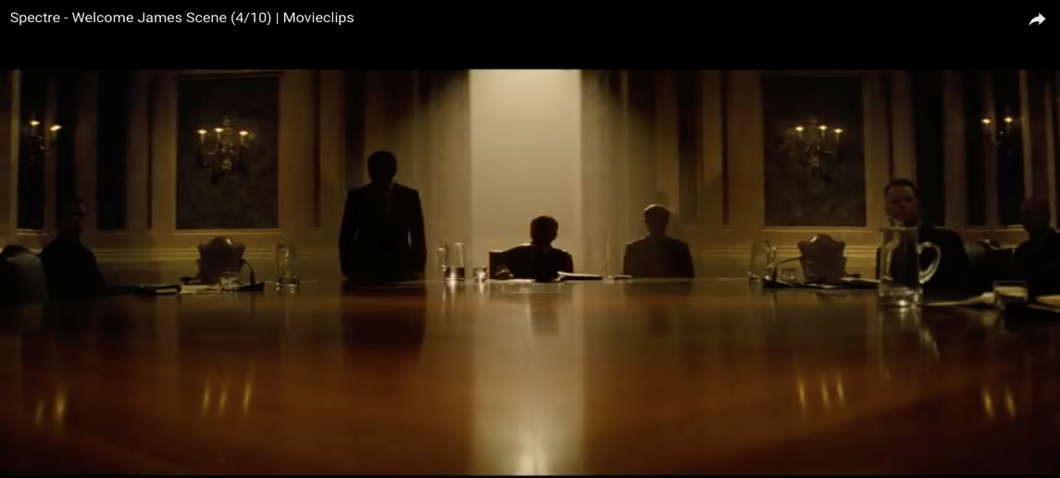 | (Evidence) Describe what happens (camera angles and actions of characters)
 | (Justification) What has the producers changed/edited so that it meets the BBFC 12 certificate criteria?
Torture scene  https://www.youtube.com/watch?v=c6tquYcA1ng  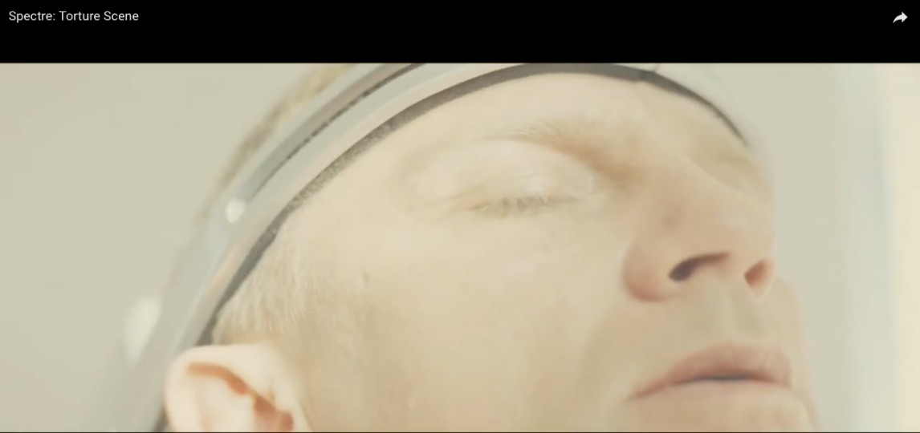 | (Evidence) Describe what happens (camera angles, props and actions of characters)
 | (Justification) What has the producers changed/edited so that it meets the BBFC 12 certificate criteria?

Potential Exam Question: 3(d) Explain the issues surrounding the age rating that Spectre received.

