

The masthead is slightly hidden behind Naomie Harris’ head which suggests that…

The Masthead of the magazine is “Pride”. The word pride has connotations of…

Coverline “The Wig Revolution Is here” links to the historical context of the magazine because…

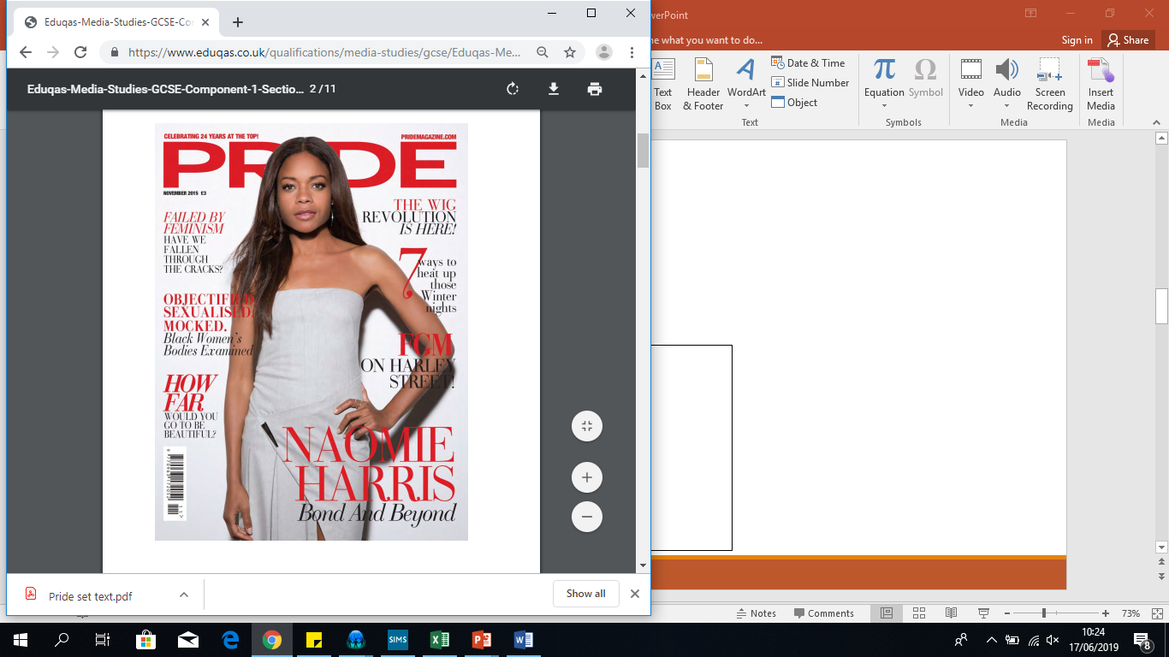

Naomie Harris is standing with her hand on her hip whilst wearing a white fitted dress is used to…

Naomie’s facial expression shows a slight smile and her directly gazing towards the audience which suggests…

The colour palette of red, white and red have connotations of…

Coverline “7 Way to Heat up Those Winter nights” has connotations of…

The long shot of Naomi allows the audience to…

The main coverline “Naomie Harris Bond and Beyond” infers…

There are many coverlines focussed on body image “How far would you go to be beautiful” and “FGM on Harley Street” which infers…