Extended writing task: Explain the ways in which “Humans” illustrates Hesmondhalgh’s points?   
  
Develop your points with examples (15 marks).

Students should;

Show a fluent understanding of Hesmondhalgh’s ideas

Show a detailed understanding of how Humans and channel 4 links to these theories

Focus on spreading financial risk and making more profit

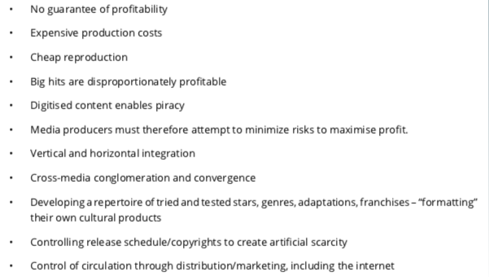

Introduction

Introduce a brief overview of Hesmondhalgh’s theory and its relevance to the set text

Outline main points of analysis to come:

Paragraph One

Point (Link to a Hesmondhalgh point):

Link to Channel 4/Humans

Evidence (1 or 2 examples)

Explanation link to Hesmondhalgh theory

Paragraph three

Point (Link to a Hesmondhalgh point):

Link to Channel 4/Humans

Evidence (1 or 2 examples)

Explanation link to Hesmondhalgh theory

Key words: vertical and horizontal integration, globalisation, spreading risk, guerrilla marketing, replicated conventions (sci-fi genre), distribution, marketing, exhibition, adaptations, no subsidy cushion

Conclusion

Summarise key points/evidence.

Paragraph two

Point (Link to a Hesmondhalgh point):

Link to Channel 4/Humans

Evidence (1 or 2 examples)

Explanation link to Hesmondhalgh theory

Paragraph four

Point (Link to a Hesmondhalgh point):

Link to Channel 4/Humans

Evidence (1 or 2 examples)

Explanation link to Hesmondhalgh theory