Vladimir Propps’ main argument is that there are seven “archetype” characters. Every media product features one or more of these “archetype” characters within.
Write a list of characters from films that you have watched that fall under each of the categories.
Hero/Protagonist
Leads the narrative/ trying to solve something or save someone.
Generally, a male.

Villain/Antagonist
Conflicts with the hero

Princess/Damsel in Distress
Generally a woman.
Some sort of prize or reward for the hero. Often weak and vulnerable and needs to be saved by the hero.
Donor
Gives the hero something – a clue / special power – which helps them to complete their quest.

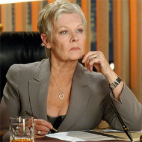
Dispatcher
An authority figure who offers a reward to the hero for completing their quest.

Helper
Helps the hero – often acts as a sidekick.
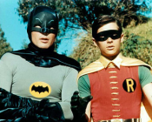

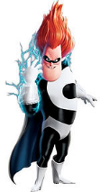
False Hero
The false hero who tries to stop the hero completing their task/quest. Sometimes starts off good but then turns bad.

